Module-1

Crystal Structure

ATMECE

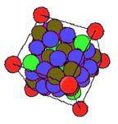
OBJECTIVES:
To learn and understand the concepts of
- Crystal structures and its types
- Importance of coordination numbers
- Imperfection in crystals & types
- Diffusion process
- Ficks diffusion law
- Factors affecting diffusion.
OUT COMES
Based on different types of crystal structure, a student can understand why some of the materials are strong, and also the relation ship between structure and property,

Crystalline Structure, Crystal Defects and Diffusion
Introduction, FCC, BCC, HCP with examples, classification of engineering materials: single crystal, polycrystalline and amorphous material. Imperfections in solids: point, line, surface and volume defects. Diffusion: diffusion mechanism, steady state. Numerical on crystal structure and diffusion. Plastic deformation of single crystal by slip and twinning,

Material Science
1

Introduction
ATMECE
One of the ways to classify engineering materials is based on their nature. Such a type of classification is given below.
- Metals and alloys: - Cast irons, Steels, Al, Copper, Silver, Gold etc
- Ceramics and Glasses: - MgO, ZnO, SiC, Silica, Concrete, Cement etc
- Polymers: - Plastics-polyethylene, PVC, PTFE, Epoxy, Polyester etc
Each of the above group materials has their own sets of properties. Every engineering material is actually known by its properties. Some of the important properties of materials are
Mechanical: strength, hardness, ductility, malleability, toughness, resilience, creep, fatigue. Physical: shape, size, density, porosity, color.
Chemical: Acidity, alkalinity, composition, corrosion resistance, atomic number, molecular weight.
Electrical: Conductivity, resistivity, dielectric constant, Thermal: Specific heat, thermal conductivity, refractoriness Aesthetic: Feel, texture, appearance, lusture All the above properties are related structure of the material.
Crystal structure is one of the most important aspects of materials science and engineering as many properties of materials depend on their crystal structures. The basic
principles of many materials characterization techniques such as X-ray diffraction (XRD), Transmission electron microscopy (TEM) are based on crystallography. Therefore, understanding the basics of crystal structures is of paramount importance.

Space lattice
- A space lattice can be defined as a three dimensional array of points, each of which has identical surroundings.
- If the periodicity along a line is a, then position of any point along the line can be obtained by a simple translation, ru = ua.
- Similarly ruv= ua + vb will repeat the point along a 2D plane, where u and v are integers.

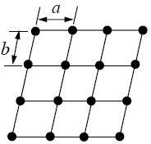
Symmetry
Symmetry refers to certain pattern or arrangement. A body is symmetrical when it is reproduced by certain operation.
In the picture below the plane looks identical after a 90o rotation. The plane has 4 fold rotation symmetry as it repeats itself 4 times (shown by the red dot) in a full 360o rotation.
17ME32

ATMECE
17ME32
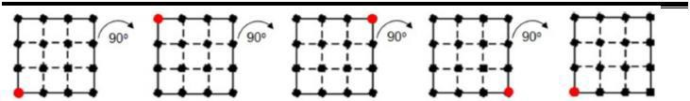

Crystal Systems
The space lattice points in a crystal are occupied by atoms. The position of any atom in the 3D lattice can be described by a vector ruvw= ua + vb + wc, where u, v and w are integers. The three unit vectors, a, b, c can define a cell as shown by the shaded region in Fig.(a) This cell is known as unit cell (Fig. b) which when repeated in the three dimensions generates the crystal structure.
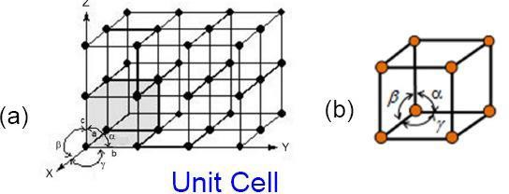

Crystal Systems

Bravais Lattice
The unit vectors a, b and c are called lattice parameters. Based on their length equality or inequality and their orientation (the angles between them, α, β and γ) a total of 7 crystal systems can be defined. With the centering (face, base and body centering) added to these, 14 kinds of 3D lattices, known as Bravais lattices, can be generated.

Crystal Systems

Cubic: a = b = c, α= β = γ = 90o
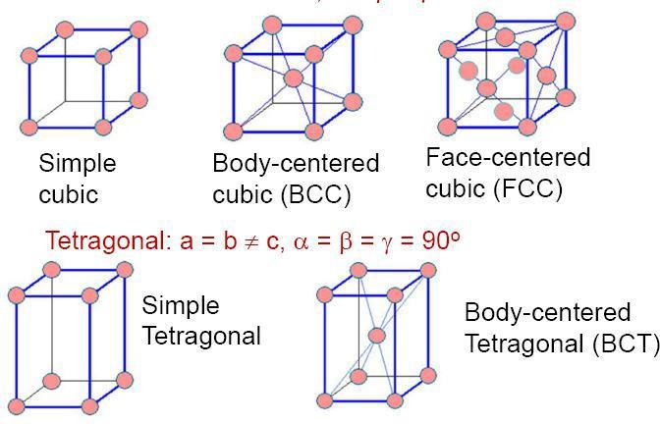

ATMECE
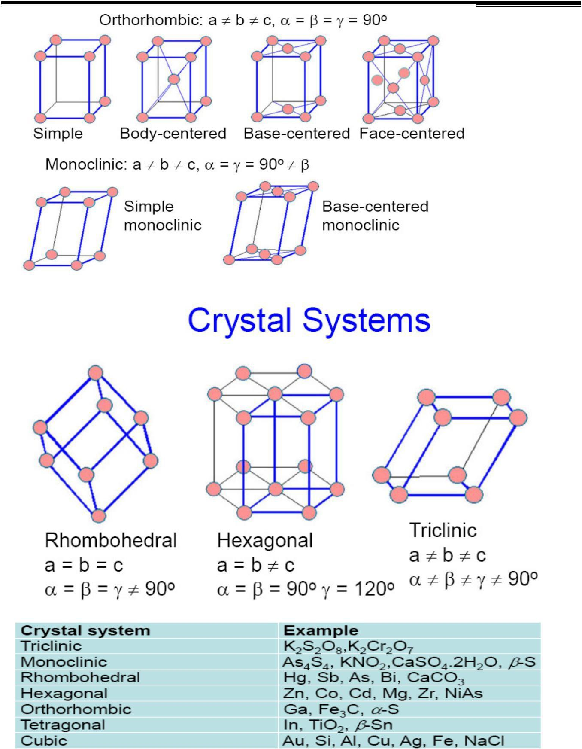

Point Coordinates
17ME32

Material Science

ATMECE
17ME32
Position of any point in a unit cell is given by its coordinates or distances from the x, y and z axes in terms of the lattice vectors a, b and c. Thus the point located at a/2 along x axis, b/3 along y axis and c/2 along z axis, as shown in the figure below, has the coordinates 1/2 1/3 1/2.
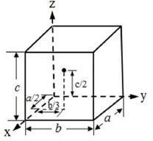
Coordination number is the number of nearest neighbor to a particular atom in the crystal
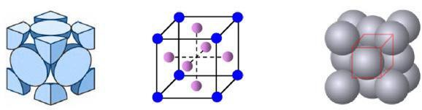
In the FCC lattice each atom is in contact with 12 neighbor atoms. FCC coordination number Z = 12 Coordination number is the number of nearest neighbor to a particular atom in the crystal
For example, the face centered atom in the front face is in contact with four corner atoms and four other face-centered atoms behind it (two sides, top and bottom) and is also touching four face- centered atoms of the unit cell in front of it.
The coordination number of BCC crystal is 8.Coordination number the body centered atom is in contact with all the eight corner atoms. Each corner atom is shared by eight unit cells and hence, each of these atoms is in touch with eight body centered atoms.
In Hexagonal lattice Z = 12. The center atom of the top face is in touch with six corner atoms, three atoms of the mid layer and other three atoms of the mid layer of the unit cell above it.
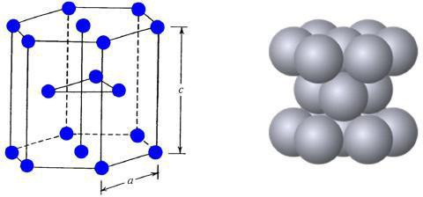

Atomic packing factor (APF) or packing efficiency indicates how closely atoms are
packed in a unit cell and is given by the ratio of volume of atoms in the unit cell and volume of the unit cell

17ME32

Atomic packing factor FCC lattice
In the FCC unit cell effective number of atoms = 8 corner atoms x (1/8) (each atom is shared by 8 unit cells) + 6 face centered atoms x1/2 (each shared by two unit cells) = 4
The corner atom C is shared by unit cells 1, 2, 3, 4 and four more in front of each of them. The face-centered atom, F is shared between cells 1 and 2.
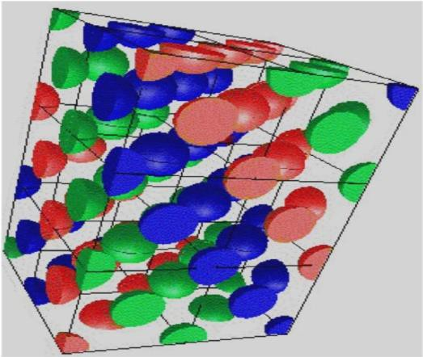
The corner atom C is shared by unit cells 1, 2, 3, 4 and four more in front of each of them. The face-centered atom, F is shared between cells 1 and 2.

Atomic packing factor FCC lattice
Considering the atoms as hard spheres of radius R
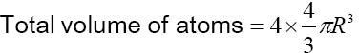
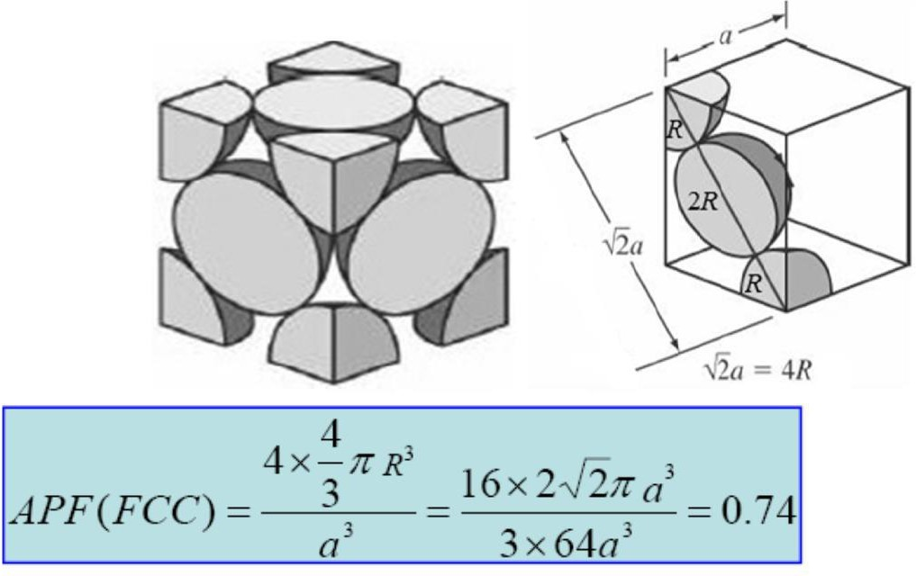
The relation between R and the FCC cell side a as shown in the figure below is 2a = 4R

BCC
For BCC crystals effective number of atoms per unit cell is 8 x 1/8 + 1 = 2 and the relation between R and a is

3a = 4R
17ME32
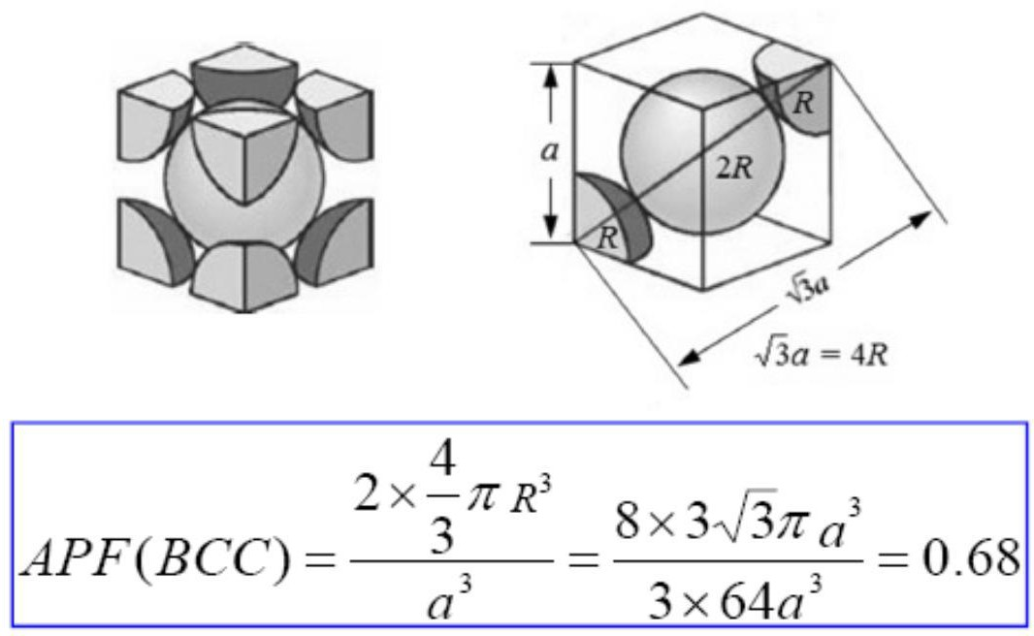

Hexagonal lattice
In the Hexagonal unit cell, number of atoms = 12 corner atoms x 1/6 (shared by six unit cells) + Two face atoms x 1/2+ 3 interior = 6.
2R = a
Unit cell volume = (6 x ½ x a x h) x c = (3 x a x a sin600) x c = 3a2 c sin600
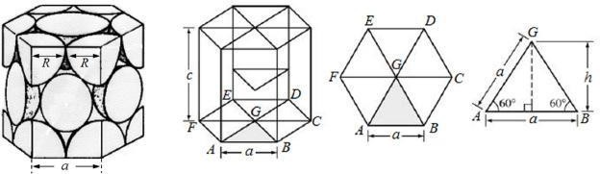

Types of lattice defects
- Point defects
- Line defects
- Surface defects
- Volume defects

Point defects
Vacancy – An atom missing from regular lattice position. Vacancies are present invariably in all materials.

ATMECE
17ME32
Interstitialcy – An atom trapped in the interstitial point (a point intermediate between regular lattice points) is called an interstitialcy.
An impurity atom at the regular or interstitial position in the lattice is another type of point defect.
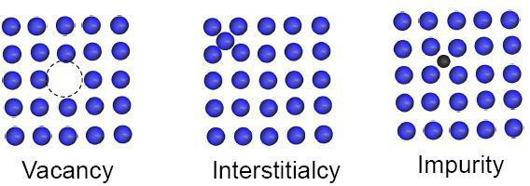

Point defects
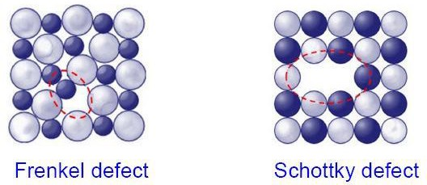
In ceramic materials point defects occur in pair to maintain the electro neutrality. A cation- vacancy and a cation-interstitial pair is known as Frenkel defect. A cation vacancy-anion vacancy pair is known as a Schottky defect.

Line defects-Dislocations
  - Dislocation is the region of localized lattice distortion which separates the slipped and unslipped portion of the crystal.
  - The upper region of the crystal over the slip plane has slipped relative to the bottom portion. The line (AD) between the slipped and unslipped portions is the dislocation.
  - The magnitude and direction of slip produced by dislocation (pink shaded) is the Burger vector, b, of the dislocation.
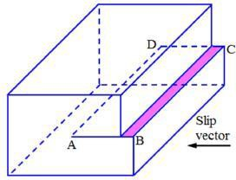

Edge Dislocations
In one type of dislocations, the Burger vector is perpendicular to the dislocation line and the distortion produces an extra half-plane above the slip plane.

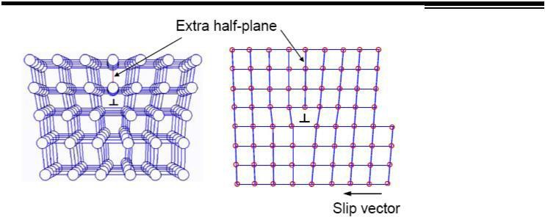
ATMECE
17ME32

Screw Dislocations
  - The other type of dislocation is the screw dislocation where the Burger vector is parallel to the dislocation line (AD).
  - The trace of the atomic planes around the screw dislocation makes a spiral or helical path (pink shade) like a screw and hence, the name.
  - Atomic positions along a screw dislocation are represented in Fig. (b)
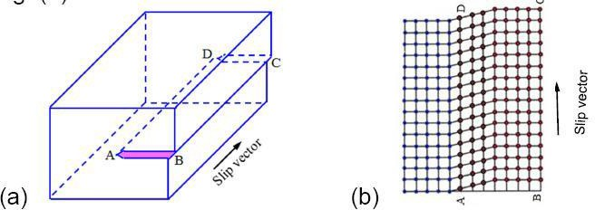

Burger Circuit
The Burger vector can be found by the gap in the Burger circuit which is obtained by moving equal distances in each direction around the dislocation.
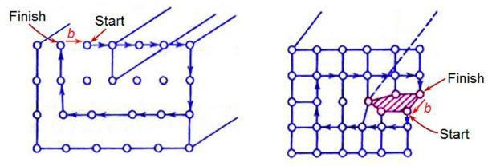

Dislocation movement and deformation
  - The theoretical shear stress to produce plastic deformation in metals, = G /2
  - G, the shear modulus for metals is in the range of = 20 -150 GPa yielding = 3 – 30 GPa
  - However, actual measured values of = 0.5 – 10 MPa.
  - This discrepancy can be explained by the presence of dislocations in the lattice.

Dislocation movement
  - Dislocations move in steps. The edge dislocation at P moves to Q in steps as depicted by the red (half-plane) and blue atoms. This movement is analogous to movement of a caterpillar.

  - When the half-plane reaches a free surface it produces a slip step.
ATMECE
17ME32
  - Edge dislocations can move only on the slip plane while screw dislocations do not have a fixed glide plane.
  - Since plastic deformation takes place by movement of dislocations, any hindrance to their motion will increase the strength of metals.
  - Dislocations assist in plastic deformation since it is easier to move the atoms at the dislocations core.
  - The movement of dislocations produces a slip step of one Burger vector or one interatomic distance.
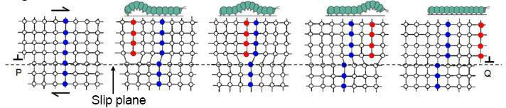

Observing dislocations
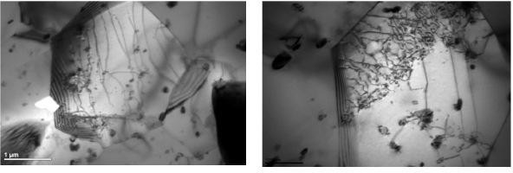
Dislocations appear as lines when observed under transmission electron microscope (TEM)

Surface defects
  - Most crystalline solids are an aggregate of several crystals. Such materials are called polycrystalline.
  - Each crystal is known as a grain. The boundary between the grains is the grain boundary (the irregular lines in Fig.a)
  - A grain boundary is a region of atomic disorder in the lattice only a few atomic diameter wide.
  - The orientation of the crystals changes across the grain boundary as shown schematically in Fig. b.
  - Grain boundaries act as obstacles to dislocation motion. Hence, presence of more grain boundaries (finer grain size) will increase the strength.

Grain boundaries
ATMECE
17ME32
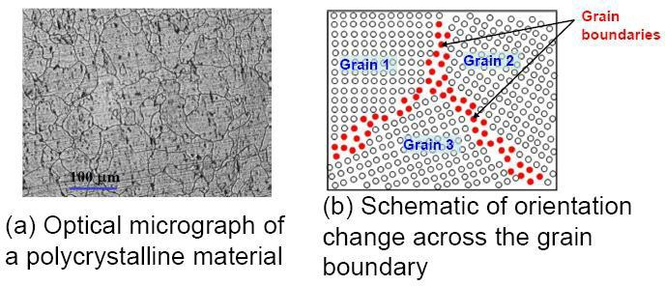
Bulk or volume defects
- Porosity
- Inclusions
- Cracks
These defects form during manufacturing processes for various reasons and are harmful to the material.

Bulk defects
  - Casting blow holes, porosity – Gas entrapment during melting and pouring. Improper welding parameters/practice
  - Shrinkage cavity due to improper risering
  - Non-metallic inclusions – Slag, oxide particles or sand entrapment
  - Cracks – Uneven heating/cooling, thermal mismatch, constrained expansion/contraction all leading to stress development

Weld defect / Casting defect
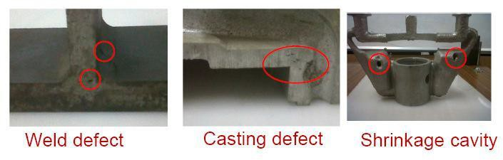
Diffusion
Diffusion Phenomena
  - Diffusion is a process of mass transport by atomic movement under the influence of thermal energy and a concentration gradient.
  - Atoms move from higher to lower concentration region.
  - If this movement is from one element to another e.g. Cu to Ni, then it is termed inter- diffusion. If the movement is within similar atoms as in pure metals, it is termed self- diffusion.

17ME32

Diffusion Mechanism
Diffusion of atoms involves movement in steps from one lattice site to the another. An empty adjacent site and breaking of bonds with the neighbor atoms are the two necessary conditions for this.

Vacancy Diffusion
This mechanism involves movement of atoms from a regular lattice site to an adjacent vacancy. Since vacancy and atoms exchange position, the vacancy flux is in the opposite direction.
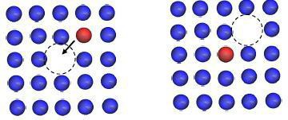

Diffusion Mechanism-Interstitial Diffusion
  - This mechanism involves migration of atoms from one interstitial site to a neighboring empty interstitial site.
  - This mechanism is more prevalent for impurity atoms such as hydrogen, carbon, nitrogen, oxygen which are small enough to fit in to an interstitial position.
  - For substitutional diffusion atoms exchange their places directly or along a ring (ring diffusion mechanism).
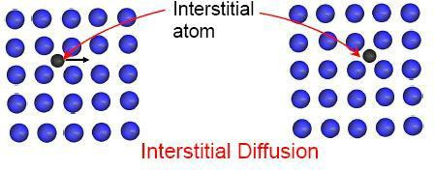
Steady-state diffusion is the situation when the diffusion flux is independent of time (e.g. diffusion of a gas through solid medium where concentration/pressure of the gas is kept constant at both the end).
Fick’s first law Describes steady-state diffusion and is given by
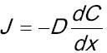
Where, J is the diffusion flux or the mass transported per unit time per unit area and dC/dx is the concentration gradient. D is known as the diffusion coefficient.

Fick’s Second Law Non- Steady state diffusion
17ME32
In most practical situations, diffusion is non-steady state i.e. diffusion flux and concentration gradient varies with time. This is described by Fick’s second law
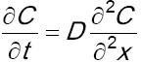
Factors affecting Diffusion Diffusing species
The magnitude of the diffusion coefficient, D, is an indication of the rate at which atoms diffuse. As the value of D is fixed for a given element in a given material, the extent of diffusion is first decided by the diffusing species itself.

Temperature
Temperature is a major factor which affects diffusion.
Temperature dependence of the diffusion coefficient is expresses as
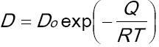
Where, Do is the pre-exponential factor and the Q is the activation energy for diffusion

Summary
Atomic arrangements in crystalline solids can be described by a network of lines called a space lattice. In metals most common crystal structure unit cells are BCC, FCC, and HCP. Crystal imperfections are present in all real crystalline materials. Dislocations occur in metal crystals and are created during solidification process. Grain boundaries are surface imperfections in metals created by crystals of different orientation meeting each other during solidification. Atomic diffusion occurs in metallic solids mainly by vacancy or substitutional mechanism and interstitial mechanism. Fick’s first law and second law states about the dependency of rate of diffusion on temperature, concentration.

Self assessment questions
- Explain APF, coordination number, space lattice, unit cell, vacancy, interstialcy, schottky defect, Frankel defect, lattice parameters.
- Calculate the packing efficiency of a BCC structure.
- Define diffusion. What are the factors affecting diffusion.
- How do you distinguish between steady state and non-steady state diffusion?
- Discuss the principle types of point defects found in crystals. Explain their significance.
- Calculate atomic radius and packing factor for BCC structure.
- State and explain the first Fick’s law of diffusion.
- Sketch the unit cell of HCP crystal structure. Calculate no of atoms per unit cell. Derive an expression for the density of atomic packing. Given C =1.633a.
- Calculate the packing efficiency of a FCC structure.
- Discuss the role of dislocation in metals. Differentiate between screw and edge dislocations with sketches.
- Explain point line and surface imperfections
- Copper has a atomic radius of 1.28 X 10-8 cm, an FCC crystal structure and an atomic weight of 63.5. Calculate its density.
- The unit cell of chromium is cubic and contains 2 atoms. Determine the dimensions of the chromium unit cell. [Given: atomic weight of Cr = 52 and density of Cr = 7.19mgm-3].

17ME32

- Copper has an FCC structure and an atomic and a n atomic radius of 0.1278mm. Calculate its density. Atomic weight of Cu = 63.54.avagadro number is = 0.602 X 1024
- Calculate the diffusion rate of carbon in iron at 7000 C. assuming the constants A = 4.9x
10-5 m2/s and E = 153.2KJ/mol.
- Nickel has FCC structure with a lattice parameter of 0.352nm. What is the value of atomic radius in nanometers?
- Iron has an atomic radius of 0.124nm, BCC structure and an atomic weight of 55.85g/mol. Calculate its density.

17ME32
ATMECE

Mechanism of Slip deformation
The group of atoms do NOT slide over each other during plastic shear deformation.The process requires too much energy
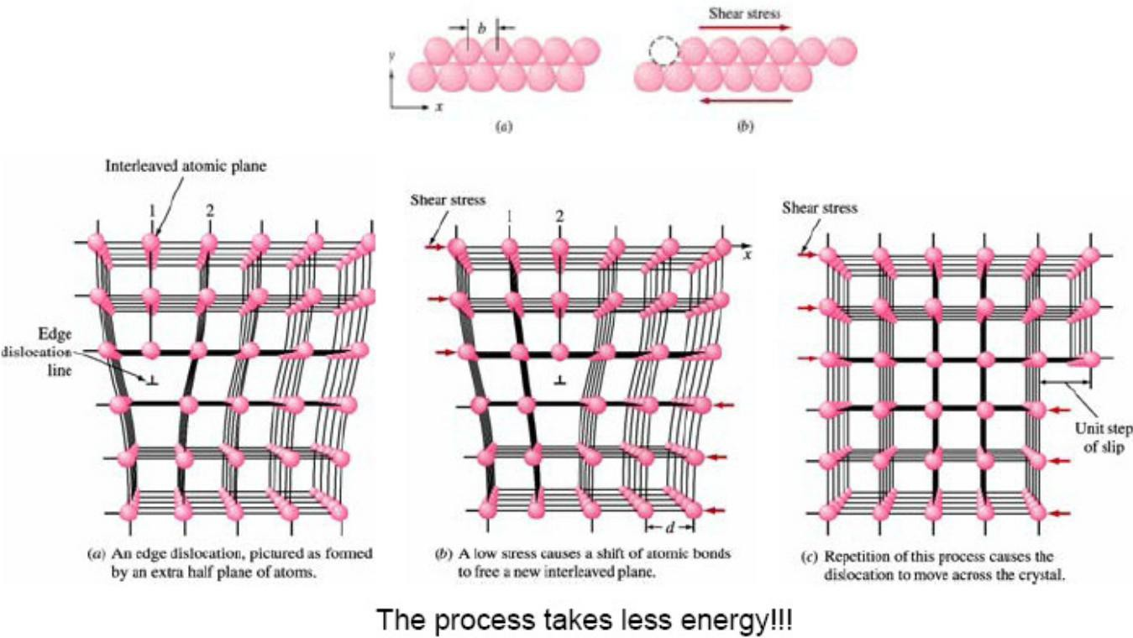

ATMECE
17ME32
Motion of Dislocations In the metal slip mechanism, dislocations move through the metal crystals like wave fronts, allowing metallic atoms to slide over each other under low shear stress deformation without fracture.
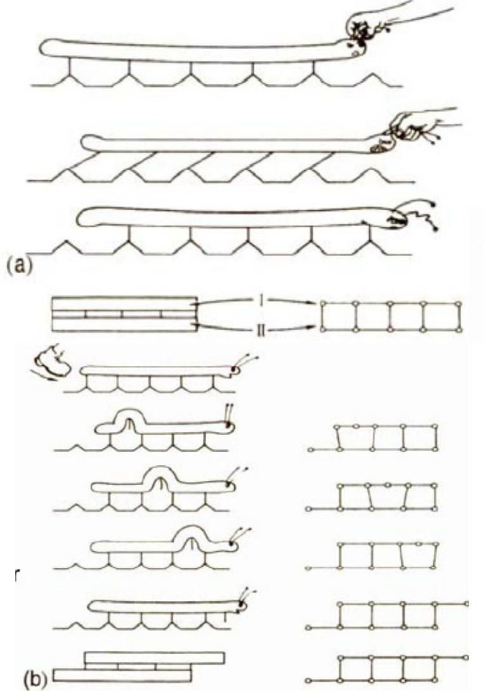

Slip Systems
Typically slip planes are the most densely packed planes (less energy is required to move from one position to another), which are the farthest separated

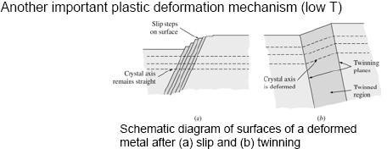
Mechanical Twinning

ATMECE
17ME32
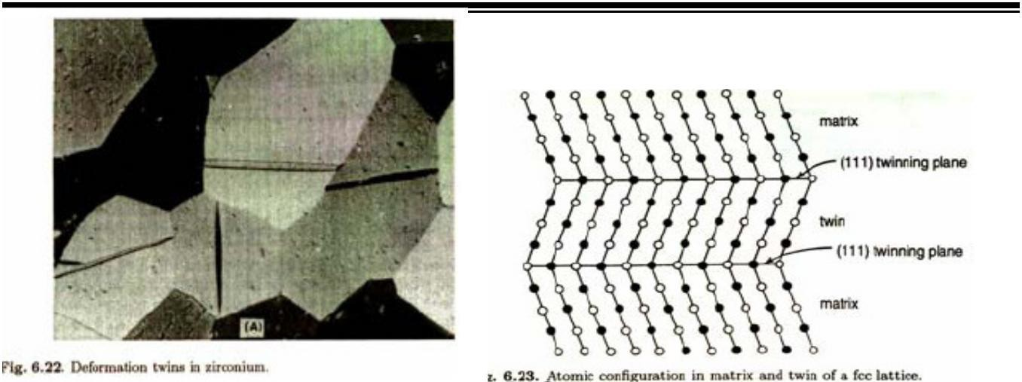

Plastic Deformations in Polycrystalline Metals
Majority of engineering alloys and metals are polycrystalline
- Grain boundaries – act as diffusion barriers for dislocation movements
- In practice: fine grain materials are stronger and harder (but less resistant to creep and corrosion)
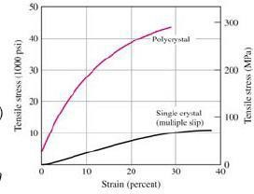

Summary
When a uniaxial stress is applied to a long metal bar, the metal deforms elastically at first and then plastically, causing permanent deformation. for many engineering designs the engineer is interested in the 0.2 percent offset yield strength, ultimate tensile strength, and elongation of a metal or alloy. These quantities are obtained from the engineering stress-strain diagram originating from a tensile test. The hardness of the material is also of engineering importance.
Plastic deformation in metals takes place by the slip process, involving dislocations. Grain boundaries at lower temperatures usually strengthen metals by providing barriers to dislocation movement.

Self assessment questions
  - Explain in detail the mechanical properties in elastic and plastic region.
  - Discuss how the slip mechanism differs in case of a poly crystal to the single crystal
  - Distinguish between slip and twinning
  - With the help of a schematic diagram explain stress-strain for mild steel under tension; explain clearly the behaviour of material till fracture.
  - Explain non linear elastic properties when a material is subjected to static tension.
  - What is work hardening? Explain the reasons for the same
  - Draw stress strain diagram for a ductile material and explain the salient points. Also explain elastic modulus, ductility and toughness.

  - Differentiate between 1) toughness and resilience 2) Ductility and brittleness
ATMECE
17ME32
  - Draw the stress strain diagram for 1, mild steel 2. Copper 3.cast iron 4. Rubber.
  - A cylindrical specimen of medium carbon steel, having an original diameter of 20mm when subjected to a tension test has fracture strength of 450Mpa. If its final diameter at fracture is 12mm, calculate the engineering stress, engineering strain and true stress.
  - A steel bar 100mm long and of square section 20mmX20mm is pulled in tension with a load of 89000N and experiences a elongation of 0.1mm. Assuming the elongation to be entirely elastic, calculate the elastic modulus of the steel.
  - A copper wire has a nominal breaking strength of 300Mpa. Its ductility is 77% reduction of area. Calculate the true stress for failure.

ATMECE

Module-2: Mechanical behavior of Materials
Creep – Phenomenon, stages of creep and creep properties.
Fatigue- Types of fatigue loads, fatigue properties, Fatigue test and S- N curves.

Fracture: Mechanism of fracture, ductile and brittle fracture, Griffith’s theory of fracture (only derivation), ductile to brittle transition.

Mechanical Properties of Metals

ATMECE

FRACTURE

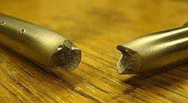

OBJECTIVES:
    - To learn and understand the concepts of
    - Fracture and types such as ductile and brittle fracture
    - Creep, propagation of creep, creep properties
    - Fatigue and its type, evaluation of fatigue parameters, factors affecting fatigue strength of a material and fatigue testing.

OUT COMES
The student should be able to understand failure of materials by different types of loads in real world.
17ME32

Material Science 25

Introduction
ATMECE
17ME32
One of the important and practical aspects of material selection in the design, development and production of new components is the possibility of failure of the component under normal operation. Failure may be defined as the inability of a material to perform the intended function, meet performance criteria although it may be still operational or perform safely and reliably even after deterioration. Every engineer should be completely aware of the concept of fracture and failure of materials. Fracture is a separation of a solid body in to two or more parts under the action of load.

Types of Fracture
Ductile materials, which includes structural steel, as well as many alloys of other metals, are characterized by their ability to yield at normal temperatures. Low carbon generally exhibits a very linear stress–strain relationship up to a well defined yield point (Fig.2). The linear portion of the curve is the elastic region and the slope is the modulus of elasticity or Young's Modulus. After the yield point, the curve typically decreases slightly because of dislocations escaping from Cottrell atmospheres. As deformation continues, the stress increases on account of strain hardening until it reaches the ultimate strength. Until this point, the cross-sectional area decreases uniformly and randomly because of Poisson contractions. The actual rupture point is in the same vertical line as the visual rupture point.
However, beyond this point a neck forms where the local cross-sectional area decreases more quickly than the rest of the sample resulting in an increase in the true stress. As shown in Fig.2.
On an engineering stress–strain curve this is seen as a decrease in the apparent

stress. However if the curve is plotted in terms of true stress and true strain the stress will continue to rise until failure. Eventually the neck becomes unstable and the specimen ruptures (fractures).
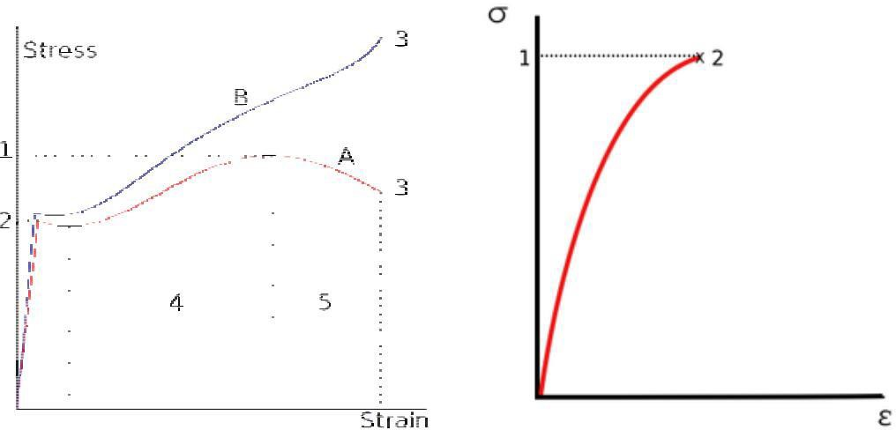
Stress strain curves for ductile and brittle materials
Less ductile materials such as medium to high carbon steels do not have a well-defined yield point. There are generally two types of yield points, upper and lower yield point. For these materials the yield strength is typically determined by the "offset yield method", by which a line is drawn parallel to the linear elastic portion of the curve and intersecting the abscissa at some

ATMECE
17ME32
arbitrary value (generally from 0.1% to 0.2%). The intersection of this line and the stress–strain curve is reported as the yield point. The elastic region is the portion of the curve where the material will return to its original shape if the load is removed. The plastic region is the portion where some permanent deformation will occur, even if the load is removed. Failure point is when the object ruptures.
Brittle materials, which include cast iron, glass, and stone, are characterized by the fact that rupture occurs without any noticeable prior change in the rate of elongation.
Brittle materials such as concrete or carbon fiber do not have a yield point, and do not strain- harden. Therefore the ultimate strength and breaking strength are the same. A typical stress-strain curve is shown in Fig.3. Typical brittle materials like glass do not show any plastic deformation but fail while the deformation is elastic. One of the characteristics of a brittle failure is that the two broken parts can be reassembled to produce the same shape as the original component as there will not be a neck formation like in the case of ductile materials. A typical stress strain curve for a brittle material will be linear. Testing of several identical specimen, cast iron, or soil, tensile strength is negligible compared to the compressive strength and it is assumed zero for many engineering applications. Glass fibers have a tensile strength stronger than steel, but bulk glass usually does not. This is because of the stress intensity factor associated with defects in the material. As the size of the sample gets larger, the size of defects also grows. In general, the tensile strength of a rope is always less than the sum of the tensile strengths of its individual fibers.
A fracture is the separation of an object or material into two, or more, pieces under the action of stress. The fracture of a solid almost always occurs due to the development of certain displacement discontinuity surfaces within the solid. If a displacement develops in this case perpendicular to the surface of displacement, it is called a normal tensile crack or simply a crack; if a displacement develops tangentially to the surface of displacement, it is called a shear crack, slip band, or dislocation.
Fracture strength, also known as breaking strength, is the stress at which a specimen fails via fracture. This is usually determined for a given specimen by a tensile test, which charts the stress-strain curve (see image). The final recorded point is the fracture strength.
Ductile materials have fracture strength lower than the ultimate tensile strength (UTS), whereas in brittle materials the fracture strength is equivalent to the UTS. If a ductile material reaches its ultimate tensile strength in a load-controlled situation, it will continue to deform, with no additional load application, until it ruptures. However, if the loading is displacement- controlled,[Note 2] the deformation of the material may relieve the load, preventing rupture.
Brittle fracture, no apparent plastic deformation takes place before fracture. In brittle crystalline materials, fracture can occur by cleavageas the result of tensile stress acting normal to crystallographic planes with low bonding (cleavage planes). In amorphous solids, by contrast, the lack of a crystalline structure results in a conchoidal fracture, with cracks proceeding normal to the applied tension.

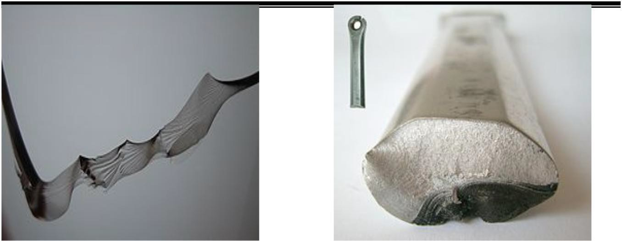
Department of mechanical Engineering
ATMECE
17ME32

1Brittle fracture in glass 2.Fracture of an aluminum crank arm. Bright: brittle fracture. Dark: fatigue fracture
Ductile fracture
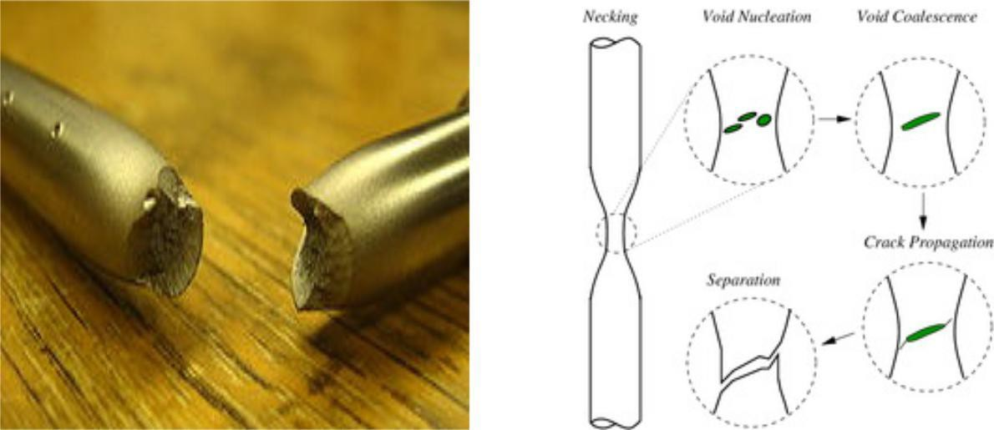
1Ductile failure of a specimen strained axially. 2 Schematic representation of the steps in ductile
fracture (in pure tension).
In ductile fracture, extensive plastic deformation (necking) takes place before fracture. The terms rupture or ductile rupture describes the ultimate failure of tough ductile materials loaded in tension. Rather than cracking, the material "pulls apart," generally leaving a rough surface. In this case there is slow propagation and absorption of large amount energy before fracture. Many ductile metals, especially materials with high purity, can sustain very large deformation of 50– 100% or more strain before fracture under favorable loading condition and environmental condition. The strain at which the fracture happens is controlled by the purity of the materials. At room temperature, pure iron can undergo deformation up to 100% strain before breaking, while cast iron or high-carbon steels can barely sustain 3% of strain. Because ductile rupture involves a high degree of plastic deformation, the fracture behavior of a propagating crack as modeled above changes fundamentally. Some of the energy from stress concentrations at the crack tips is dissipated by plastic deformation before the crack actually propagates. The basic steps are: void formation, void coalescence (also known as crack formation), crack propagation, and failure, often resulting in a cup-and-cone shaped failure surface.

Crack separation modes
ATMECE
17ME32
There are three ways of applying a force to enable a crack to propagate:

Mode I crack – Opening mode (a tensile stress normal to the plane of the crack)

Mode II cracks – Sliding mode (a shear stress acting parallel to the plane of the crack and perpendicular to the crack front)

Mode III crack – Tearing mode (a shear stress acting parallel to the plane of the crack and parallel to the crack front)
Crack initiation and propagation accompany fracture. The manner through which the crack propagates through the material gives great insight into the mode of fracture. In ductile materials (ductile fracture), the crack moves slowly and is accompanied by a large amount of plastic deformation. The crack will usually not extend unless an increased stress is applied. On the other hand, in dealing with brittle fracture, cracks spread very rapidly with little or no plastic deformation. The cracks that propagate in a brittle material will continue to grow and increase in magnitude once they are initiated. Another important mannerism of crack propagation is the way in which the advancing crack travels through the material. A crack that passes through the grains within the material is undergoing transgranular fracture. However, a crack that propagates along the grain boundaries is termed an intergranular fracture.
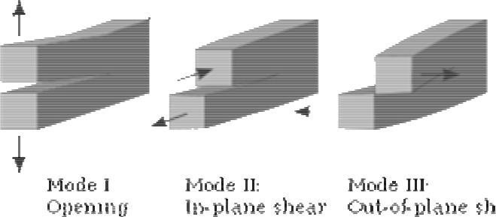

Creep
In materials science, creep (sometimes called cold flow) is the tendency of a solid material to move slowly or deform permanently under the influence of mechanical stresses. It can occur as a result of long-term exposure to high levels of stress that are still below the yield strength of the material. Creep is more severe in materials that are subjected to heat for long periods, and generally increases as they near their melting point.
The rate of deformation is a function of the material properties, exposure time, exposure temperature and the applied structural load. Depending on the magnitude of the applied stress and its duration, the deformation may become so large that a component can no longer perform its function — for example creep of a turbine blade will cause the blade to contact the casing, resulting in the failure of the blade. Creep is usually of concern to engineers and metallurgists when evaluating components that operate under high stresses or high temperatures. Creep is a deformation mechanism that may or may not constitute a failure mode. For example, moderate creep in concrete is sometimes welcomed because it relieves tensile stresses that might otherwise lead to cracking.

ATMECE
Unlike brittle fracture, creep deformation does not occur suddenly upon the application of stress. Instead, strain accumulates as a result of long-term stress. Therefore, creep is a "time-dependent" deformation.
The temperature range in which creep deformation may occur differs in various materials. For example, tungsten requires a temperature in the thousands of degrees before creep deformation can occur, while ice will creep at temperatures near 0 °C (32 °F).[1] As a general guideline, the effects of creep deformation generally become noticeable at approximately 30% of the melting point (as measured on a thermodynamic temperature scale such as kelvin or rankine) for metals, and at 40–50% of melting point for ceramics. Virtually any material will creep upon approaching its melting temperature. Since the creep minimum temperature is related to the melting point, creep can be seen at relatively low temperatures for some materials. Plastics and low-melting- temperature metals, including many solders, can begin to creep at room temperature, as can be seen markedly in old lead hot-water pipes. Glacier flow is an example of creep processes in ice.

In the initial stage, or primary creep, the strain rate is relatively high, but slows with increasing time. This is due to work hardening. The strain rate eventually reaches a minimum and becomes near constant. This is due to the balance between work hardening and annealing (thermal softening). This stage is known as secondary or steady-state creep. This stage is the most understood. The characterized "creep strain rate" typically refers to the rate in this secondary stage. Stress dependence of this rate depends on the creep mechanism. In tertiary creep, the strain rate exponentially increases with stress because of necking phenomena.

Mechanisms of creep
The mechanism of creep depends on temperature and stress. Various mechanisms are:

- Bulk diffusion (Nabarro-Herring creep)
- Climb — here the strain is actually accomplished by climb
- Climb-assisted glide — here the climb is an enabling mechanism, allowing dislocations to get around obstacles
- Grain boundary diffusion (Coble creep)
- Thermally activated glide — e.g., via cross-slip

Fatigue
Fatigue is the weakening of a material caused by repeatedly applied loads. It is the progressive and localized structural damage that occurs when a material is subjected to cyclic loading. The nominal maximum stress values that cause such damage may be much less than the strength of the material typically quoted as the ultimate tensile stress limit, or the yield stress limit.

ATMECE
Fatigue occurs when a material is subjected to repeat loading and unloading. If the loads are above a certain threshold, microscopic cracks will begin to form at the stress concentrators such as the surface, persistent slip bands (PSBs), and grain interfaces. Eventually a crack will reach a critical size, the crack will propagate suddenly, and the structure will fracture. The shape of the structure will significantly affect the fatigue life; square holes or sharp corners will lead to elevated local stresses where fatigue cracks can initiate. Round holes and smooth transitions or fillets will therefore increase the fatigue strength of the structure.

Characteristics of fatigue

- In metal alloys, when there are no macroscopic or microscopic discontinuities, the process starts with dislocation movements, which eventually form persistent slip bands that become the nucleus of short cracks.
- Macroscopic and microscopic discontinuities as well as component design features which cause stress concentrations (holes, keyways, sharp changes of direction etc.) are common locations at which the fatigue process begins.
- Fatigue is a process that has a degree of randomness (stochastic), often showing considerable scatter even in well controlled environments.
- Fatigue is usually associated with tensile stresses but fatigue cracks have been reported due to compressive loads.[7]
- The greater the applied stress range, the shorter the life.
- Fatigue life scatter tends to increase for longer fatigue lives.
- Damage is cumulative. Materials do not recover when rested.
- Fatigue life is influenced by a variety of factors, such as temperature, surface finish, metallurgical microstructure, presence of oxidizing or inert chemicals, residual stresses, scuffing contact (fretting), etc.
- Some materials (e.g., some steel and titanium alloys) exhibit a theoretical fatigue
limit below which continued loading does not lead to fatigue failure.
- In recent years, researchers have found that failures can occur below the theoretical fatigue limit at very high fatigue lives (109 to 1010 cycles). An ultrasonic resonance technique is used in these experiments with frequencies around 10–20 kHz.
- High cycle fatigue strength (about 104 to 108 cycles) can be described by stress-based
parameters. A load-controlled servo-hydraulic test rig is commonly used in these tests, with frequencies of around 20–50 Hz. Other sorts of machines—like resonant magnetic machines—can also be used, to achieve frequencies up to 250 Hz.
- Low cycle fatigue (loading that typically causes failure in less than 104 cycles) is associated with localized plastic behavior in metals; thus, a strain-based parameter should be used for fatigue life prediction in metals. Testing is conducted with constant strain amplitudes typically at 0.01–5 Hz.

Factors that affect fatigue-life

Cyclic stress state: Depending on the complexity of the geometry and the loading, one or more properties of the stress state need to be considered, such as stress amplitude, mean stress, biaxiality, in-phase or out-of-phase shear stress, and load sequence,

ATMECE
17ME32
Geometry: Notches and variation in cross section throughout a part lead to stress concentrations where fatigue cracks initiate.

Surface quality: Surface roughness can cause microscopic stress concentrations that lower the fatigue strength. Compressive residual stresses can be introduced in the surface by e.g. shot peening to increase fatigue life. Such techniques for producing surface stress are often referred to as peening, whatever the mechanism used to produce the stress. Low plasticity burnishing, laser peening, and ultrasonic impact treatment can also produce this surface compressive stress and can increase the fatigue life of the component. This improvement is normally observed only for high- cycle fatigue.

Material Type: Fatigue life, as well as the behavior during cyclic loading, varies widely for different materials, e.g. composites and polymers differ markedly from metals.

Residual stresses: Welding, cutting, casting, grinding, and other manufacturing processes involving heat or deformation can produce high levels of tensile residual stress, which decreases the fatigue strength.

Size and distribution of internal defects: Casting defects such as gas porosity voids, non- metallic inclusions and shrinkage voids can significantly reduce fatigue strength.

Air or Vacuum: Certain materials like Metals are more prone to fatigue in air than in a vacuum. Depending upon the level of humidity and temperature, the lifetime for metals such as aluminum or iron might be as much as 5 to 10 times greater in a vacuum. This is mostly due to the effect of the oxygen and water vapour in the air which will aggressively attack the material and so encourage the propagation of cracks. Other environments such as oil or seawater may reduce the fatigue life at an even greater rate.

Direction of loading: For non-isotropic materials, fatigue strength depends on the direction of the principal stress.

Grain size: For most metals, smaller grains yield longer fatigue lives, however, the presence of surface defects or scratches will have a greater influence than in a coarse grained alloy.

Environment: Environmental conditions can cause erosion, corrosion, or gas-phase embrittlement, which all affect fatigue life. Corrosion fatigue is a problem encountered in many aggressive environments.

Temperature: Extreme high or low temperatures can decrease fatigue strength.

Crack Closure: Crack closure is a phenomenon in fatigue loading, during which the crack will tend to remain in a closed position even though some external tensile force is acting on the material. During this process the crack will open only at a nominal stress above a particular crack opening stress. This is due to several factors such as plastic deformation or phase transformation during crack propagation, corrosion of crack surfaces, presence of fluids in the crack, or

ATMECE
17ME32
roughness at cracked surfaces etc. this will provide a longer fatigue life for the material than expected, by slowing the crack growth rate.

S-N curve
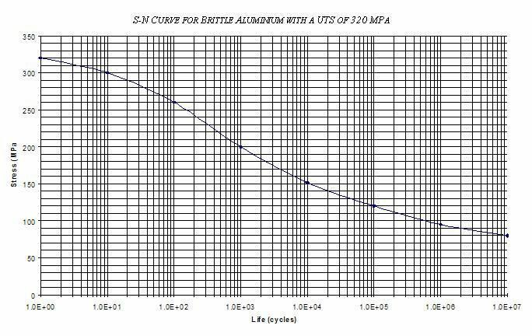
In high-cycle fatigue situations, materials performance is commonly characterized by an S-N curve, also known as a Wöhler curve. This is a graph of the magnitude of a cyclic stress (S) against the logarithmic scale of cycles to failure (N).
curves are derived from tests on samples of the material to be characterized (often called coupons) where a regular sinusoidal stress is applied by a testing machine which also counts the number of cycles to failure. This process is sometimes known as coupon testing. Each coupon test generates a point on the plot though in some cases there is arunout where the time to failure exceeds that available for the test (see censoring). Analysis of fatigue data requires techniques from statistics, especially survival analysis and linear regression.
The progression of the S-N curve can be influenced by many factors such as corrosion, temperature, residual stresses, and the presence of notches. The Goodman-Line is a method to estimate the influence of the mean stress on the fatigue strength.

Summary
Metals under load fail by fracture. Fracture is the separation of an object or material into two, or more, pieces under the action of stress. A fracture may be ductile or brittle. A ductile fracture is preferred over brittle fracture. Creep (sometimes called cold flow) is the tendency of a solid material to move slowly or deform permanently under the influence of mechanical stresses. It can occur as a result of long-term exposure to high levels of stress that are still below the yield strength of the material. Fatigue is the weakening of a material caused by repeatedly applied loads. It is the progressive and localized structural damage that occurs when a material is subjected to cyclic loading.

Self assessment questions

    - How fractures are classified? State and explain different types of fracture giving appearance of the fracture in each case.

    - Explain with neat figure ductile fracture using both stress-strain and stages of fracture
ATMECE
17ME32
    - Explain with sketch brittle fracture in materials.
    - Why brittle fracture is is dangerous?
    - Explain with sketch, the ductile to brittle transition in the materials.
    - Derive an expression for the critical resolved shear stress for slip
    - Explain Griffith’s theory of brittle fracture.
    - Sketch a typical creep curve and explain different stages of creep.
    - Discuss any two mechanisms for creep.
    - Define creep strength, creep life and creep limit.
    - How fatigue strength of materials is is determined?
    - Discuss on fatigue properties.
    - With the help of a sketch, discuss the different types of stress cycles which bring about fatigue failure.
    - What is meant by stress relaxation? Explain with figure.
    - Explain factors affecting fatigue life.

Module-3

SOLIDIFICATION

ATMECE
17ME32
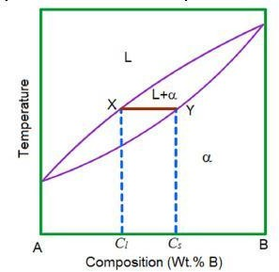

Module –3: Solidification and Phase Diagrams
Mechanism of solidification, homogeneous and heterogeneous solidification, Hume Rothary rules, substitution and interstitial solid solutions. Construction of phase diagram for binary systems, types of phase diagrams, Gibbs phase rule. lever rule. Iron carbon equilibrium diagram and invariant reactions. Numerical on lever rule.

OBJECTIVES:
- To learn and understand the concepts of solidification
- Solid Solution and types
- Phase and phase equilibrium
- Nucleation and types of nucleation
- Crystal growth
- Phase diagrams

OUT COMES
The student should be able to understand the mechanism of solidification

Introduction
The solidification of metals and alloys is an important industrial process since most metals are melted and then cast in to a semi finished or finished shape. When molten metals are cast, solidification starts at the walls of the mould as it is being cooled. The solidification of alloy takes place not at a specific temperature but over a range of temperatures. While the alloy is in this range, it has a pasty form that consists of solid, tree like structures called dendrites and liquid metals. The size and shape of the dendrites depends on the cooling rate. The study of dendrites is important because they influence compositional variations, porosity and segregation and therefore properties.

ATMECE

Component – is either pure metal and/or compounds of which an alloy is composed. The components of a system may be elements, ions or compounds. They refer to the independent chemical species that comprise the system.

System – it can either refer to a specific body of material under consideration or it may relate to the series of possible alloys consisting of the same components but without regard to alloy composition.

Solid solution – it consists of atoms of at least two different types where solute atoms occupy either substitutional or interstitial positions in the solvent lattice and the crystal structure of the solvent is maintained.

Solubility limit – for almost all alloy systems, at a specific temperature, a maximum of solute atoms can dissolve in solvent phase to form a solid solution. The limit is known as solubility limit. In general, solubility limit changes with temperature. If solute available is more than the solubility limit that may lead to formation of different phase, either a solid solution or compound.

Phase equilibrium – it refers to the set of conditions where more than one phase may exist. It can be reflected by constancy with time in the phase characteristics of a system. In most metallurgical and materials systems, phase equilibrium involves just solid phases. However the state of equilibrium is never completely achieved because of very slow rate of approach of equilibrium in solid systems. This leads to non-equilibrium or meta-stable state, which may persist indefinitely and of course, has more practical significance than equilibrium phases. An equilibrium state of solid system can be reflected in terms of characteristics of the microstructure, phases present and their compositions, relative phase amounts and their spatial arrangement or distribution.

Kinetics of nucleation and growth
Structural changes in metallic systems usually take place by nucleation and growth whether it is just a phase change within one of the three states, or a simple structural rearrangement within a single phase, or a phase transformation. An equilibrium phase diagram presents the phases and phase changes expected under equilibrium conditions, but it provides no information about the rates of transformation. Although changes in pressure, composition, or temperature can cause phase transformations, it is temperature changes that are more important. From a micro structural standpoint, the first process to accompany a phase transformation is nucleation (i.e. the formation of very small particles or nuclei of the product phase from the parent phase) of the new phase particles which are capable of growing. The second stage is growth, in which the nucleated particles increase their size. The transformation reaches completion if growth of these new phase particles is allowed to proceed until the equilibrium fraction is attained.
Both nucleation and growth require that the accompanying free energy change be negative. Consequently, the super-heating or super-cooling that is necessary for a phase change is to be expected. That is a transformation cannot tale place precisely at the equilibrium transformation
17ME32

Material Science
36

ATMECE
17ME32
temperature because at that temperature free energies of phases are equal. In addition to temperature, two other factors that affect transformation rate – first, diffusion controlled rearrangement of atoms because of compositional and/or crystal structural differences; second, difficulty encountered in nucleating small particles via change in surface energy associated with the interface. Diffusion limits both the nucleation and growth rates in many cases.
With the nucleation of new particle, new interface is created between the particle and liquid. This interface will have positive energy that must be supplied during the transformation process. A tiny particle has a large surface area to volume ratio and therefore be unstable. Thus energy of the surface can effectively prevent the initial formation of a tiny particle. A particle said to have nucleated when it becomes stable and will not disappear due to thermal fluctuations. After a particle attained a critical size, it can grow further with a continuous decrease in energy. The surface energy is no longer a dominant factor in the growth process.

Nucleation
Homogeneous nucleation, the probability of nucleation occurring at any given site is identical to that at any other site within the volume of the parent phase. When a pure liquid metal is cooled below its equilibrium freezing temperature to a sufficient degree, numerous homogeneous nuclei are created by slow-moving atoms bonding together. Homogeneous nucleation usually requires a considerable amount of under cooling (cooling a material below the equilibrium temperature for a given transformation without the transformation occurring). Under cooling enhances the formation of nuclei that eventually grow. If f is the free energy change accompanying the formation of a spherical new phase particle,
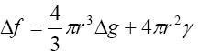
where r is the radius of the particle, g is the Gibbs free energy change per unit volume and γ is the surface energy of the interface.
Heterogeneous nucleation, the probability of nucleation occurring at certain preferred sites is much greater than that at other sites. During solidification, inclusions of foreign particles (inoculants), walls of container holding the liquid provide preferred sites. Irregularities in crystal structure such as point defects and dislocations possess strain energy. In solid-solid transformation, foreign inclusions, grain boundaries, interfaces, stacking faults and dislocations can act as preferred sites for nucleation as the strain energy associated with them will be reduced. The released strain energy can reduce the energy requirements for free energy change, f. Therefore, nucleation proceeds with a smaller critical radius. A majority of reactions are initiated by some type of heterogeneous nucleation which is common among the two types.

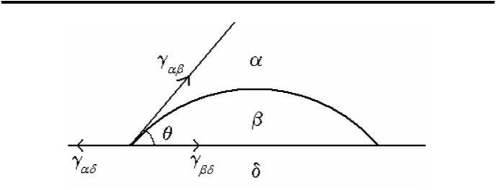

Crystal Growth
Figure-: Schematic of heterogeneous nucleation.

Many transformations occur as a result of continuous formation of critical nuclei in the parent phase and the subsequent growth of the particles. Growth is the increase in size of the particle after it has nucleated i.e. growth kinetics become important once an embryo has exceeded the critical size and become a stable nucleus. Growth may proceed in two
ATMECE
17ME32
radically different manners. In one type of growth, individual atoms move independently from the parent to the product phase, thus it is diffusion controlled and is thermally activated. In the other type of growth that occurs in solid-solid transformations many atoms move cooperatively without thermal assistance. Growth that is diffusion controlled is more common the other. Growth usually occurs by the thermally activated jump of atoms from the parent phase to the product phase. The unit step in the growth process thus consists of an atom leaving the parent phase and jumping across the interface to join the product phase. At the equilibrium temperature, both phases have the same free energy, hence the frequency of jumps from parent phase to product phase will be equal to that from product phase to parent phase i.e. the net growth rate is zero. At lower temperatures, product phase is expected to have lower free energy, and thus a net flow of atoms from parent phase to product phase. This net flux of atoms results in interface motion i.e. growth rate is taken as the rate of increase of a linear dimension of a growing particle. As a function of temperature, the growth rate first increases with increasing degree of super cooling, but eventually slows-down as thermal energy decreases. This is same as for nucleation; however the maximum in the growth rate usually occurs at a higher temperature than the maximum in the nucleation rate.

Solid Solution
When two metals are mixed together they form an alloy if one metal is soluble in the other one in solid state. Therefore, an alloy is a solid solution of two or more metals.
Primarily there are two types of solid solutions -
Substitutional – Solute atoms occupy the regular lattice sites of the parent metal (solvent). Substitutional solid solutions can be random (Cu-Ni) or ordered (Cu-Au).
Interstitial – Solute atoms occupy the interstitial positions (Steel – C solute atoms in Fe) .

ATMECE
17ME32
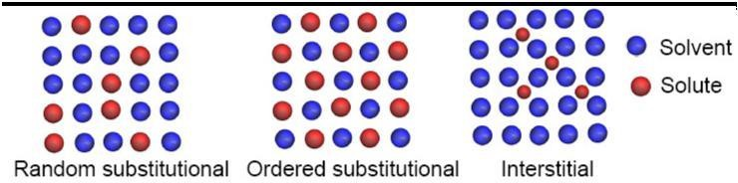

Hume-Rothery Rules
Formation of substitutional solid solutions between two metals is governed by a set of rules known as Hume-Rothery rules
- Size difference between the atoms of solute and the parent metal should be less than 15%.
- The electronegetivity difference between the metals should be small (minimum chemical affinity to each other).
- The solubility of a metal with higher valence in a solvent of lower valence is more compared to the reverse situation e.g. Zn is much more soluble in Cu than Cu in Zn.
- For complete solubility over the entire range of compositions the crystal structures of the solute and the solvent must be the same.

Phase
A phase can be defined as a physically distinct and chemically homogeneous portion of a system that has a particular chemical composition and structure.
Water in liquid or vapor state is single phase. Ice floating on water is an example two phase system.

Gibbs Phase rule
The number of degrees of freedom, F (no. of independently variable factors), number of components, C, and number of phases in equilibrium, P, are related by Gibbs phase rule as
F = C – P + 2
Number of external factors = 2 (pressure and temperature).
For metallurgical system pressure has no appreciable effect on phase equilibrium and hence, F = C – P + 1

Phase Diagrams

One component system
The simplest phase diagram is the water which is a one component system. It is also known as pressure-temperature or P-T diagram. Two phases exist along each of the three phase boundaries. At low pressure (0.006 atm) and temperature (0.010C) all the three phases coexist at a point called triple point.

ATMECE
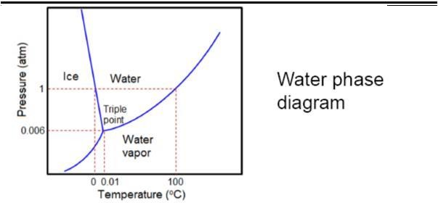

Binary Phase diagrams
A binary phase is a two component system. Binary phase diagrams are most commonly used in alloy designing.
The simplest binary system is the Cu-Ni which exhibits complete solubility in liquid and solid state.
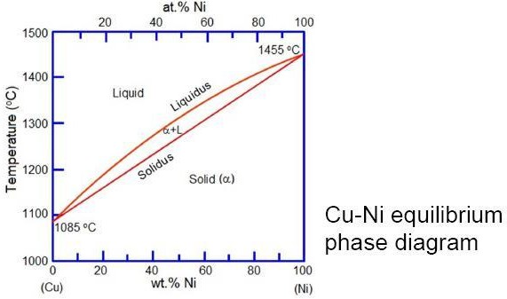
- The line above which the alloy is liquid is called the liquidus line. At temperature just below this line crystals of α solid solution start forming.
- The line below which solidification completes is called solidus line. Hence, only α solid solution exists at any temperature below the solidus line.
- The intermediate region between liquidus and solidus lines is the two-phase region where liquid and solid coexists.

ATMECE
- It can be noted that the two metals are soluble in each other in the entire range of compositions in both liquid and solid state. This kind of system is known as ‘Isomorphous’ system.

The Tie line
The composition of phases in the two-phase region is not same.
To find the composition of the individual phases in the two phase region, a horizontal line (XY), called tie line, is drawn and its intercepts on the liquidus and solidus lines, Cl and Cs, are taken as the composition of the liquid and solid respectively.

Lever rule
The relative fractions of the phases at a given temperature for an alloy composition Co is obtained by the lever rule. This rule gives the fraction of a phase by the ratio of the lengths of the tie line between Co and composition of the other phase to the total length of the tie line. For example, fraction solid, fs is given by
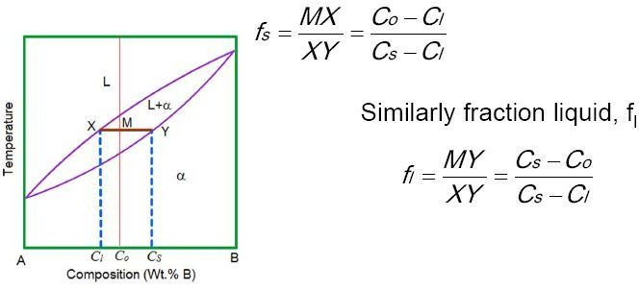

Phase diagrams- Limited solubility
Not all metals are completely soluble in each other. Distinctions can be made between two types of solid solutions with limited solubility – (i) Eutectic and (ii) Peritectic.
When the melting points of two metals are comparable, a eutectic system forms while a peritectic results when melting points are significantly different.
A eutectic reaction is defined as the one which generates two solids from the liquid at a given temperature and composition, L → α + β

Peritectic is Liquid + Solid 1 → Solid 2 (L + α→β)
ATMECE
In both the cases three phases (two solids and a liquid) coexist and the degrees of freedom F = 2 – 3 + 1 = 0. This is known as invariant (F = 0) reaction or transformation.

Eutectic Phase diagram
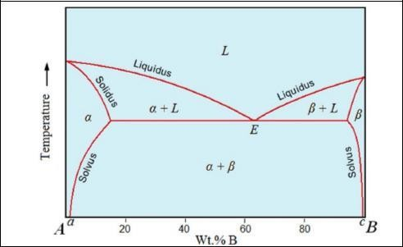
Three phases (L+α+β) coexist at point E. This point is called eutectic point or composition. Left of E is called hypoeutectic whereas right of E is called hypereutectic.
A eutectic composition solidifies as a eutectic mixture of αand β phases. The microstructure at room temperature (RT) may consist of alternate layers or lamellae of α andβ.
In hypoeutectic alloys the α phase solidifies first and the microstructure at RT consists of this α phase (called proeutecticα) and the eutectic (α+β) mixture. Similarly hypereutectic alloys consist of proeutectic and the eutectic mixture. The melting point at the eutectic point is minimum. That’s why Pb-Sn eutectic alloys are used as solders. Other eutectic systems are Ag-Cu, Al-Si, Al-Cu.

Peritectic Phase diagram
L +α→β. An alloy cooling slowly through the peritectic point, P, the α phase will crystallize first
just below the liquidus line. At the peritectic temperature, TP all of the liquid and α will convert toβ. Any composition left of P will generate excess α and similarly compositions right of P will give rise to an excess of liquid.
Peritectic systems – Pt - Ag, Ni - Re, Fe - Ge, Sn-Sb (babbit).

Summary
The solidification of alloy takes place not at a specific temperature but over a range of temperatures. While the alloy is in this range, it has a pasty form that consists of solid, tree like structures called dendrites and liquid metals. Formation of substitutional solid solutions between two metals is governed by a set of rules known as Hume-Rothery rules. The relative fractions of the phases at a given temperature for an alloy composition are obtained by the lever rule. A eutectic reaction is defined as the one which generates two solids from the liquid at a given temperature and composition, L → α +β. Peritectic is Liquid + Solid 1 → Solid 2 (L +α→β)
In both the cases three phases (two solids and a liquid) coexist and the degrees of freedom F = 2 – 3 + 1 = 0. This is known as invariant (F = 0) reaction or transformation.

Self assessment questions
- Define nucleation. Derive an expression for the critical size of the nucleus for homogeneous nucleation.
- State and explain Gibb’s phase rule. How it can be applied to a unary phase diagram? Show that degrees of freedom at triple point are zero.
- Describe the solidification mechanism in pure metal. Distinguish between homogeneous and heterogeneous nucleation.
- Discuss the factors worked out by Hume-Rothery that governs the formation of an ideal solid solution.
- What are the different types of solidification
- Explain with neat sketches the different stages of mechanisms of solidification.
- Define solid solution. Explain substitutional and interstitial solid solution.
- Explain the factors governing the formation of substitutional solid solution.
- With the help of cooling curves ex[lain the solidification of pure metal and binary eutectic alloy
- A binary alloy A-50% B contains at a particular temperature two solid phases α and β are 5% B and 95% B respectively. calculate the amount of α and β in the alloy.

ATMECE
17ME32
IRON CARBON DIAGRAM
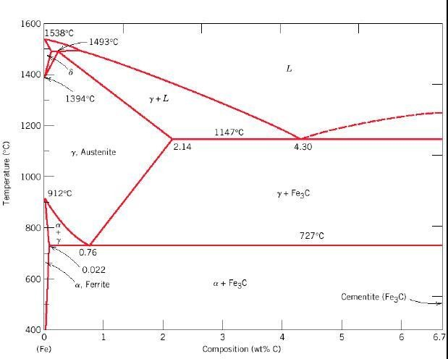

OBJECTIVES:
- To construct equilibrium diagrams involving complete and partial solubility,
- To understand lever rule
- To understand Iron carbon equilibrium diagram description of phases,
- To know solidification of steels and cast irons invariant reactions.

Outcomes:
1. Student can better understand the phase diagrams those are important to design and control of heat treating process and to obtain desirable microstructures.
ATMECE
17ME32

Introduction
A phase in a material is a region that differs in its microstructure and /or composition from another region. Phase diagrams are graphical reprentations of what phases are present in a materials system at various temperatures and pressures and compositions. Most phase diagrams are constructed by using equilibrium conditions and used by engineers and scientists to understand and predict many aspects of the behaviour of materials.
The Iron–Iron Carbide (Fe–Fe3C) Phase Diagram In their simplest form, steels are alloys of Iron (Fe) and Carbon (C). The Fe-C phase diagram is a fairly complex one, but we will only consider the steel part of the diagram, up to around 7% Carbon.
Phases in Fe–Fe3C Phase Diagram α- ferrite - solid solution of C in BCC Fe
- Stable form of iron at room temperature.
- The maximum solubility of C is 0.022 wt%
- Transforms to FCC γ-austenite at 912 °C

γ-austenite - solid solution of C in FCC Fe
- The maximum solubility of C is 2.14 wt %.
- Transforms to BCC δ-ferrite at 1395 °C
- Is not stable below the eutectic temperature (727 ° C) unless cooled rapidly (Chapter 10) δ-ferrite solid solution of C in BCC Fe
- The same structure as α-ferrite
- Stable only at high T, above 1394 °C
- Melts at 1538 °C

Fe3C (iron carbide or cementite)
- This intermetallic compound is metastable, it remains as a compound indefinitely at room T, but decomposes (very slowly, within several years) into α-Fe and C (graphite) at 650 - 700 °C

Fe-C liquid solution
A few comments on Fe–Fe3C system
C is an interstitial impurity in Fe. It forms a solid solution with α, γ, δ phases of iron. Maximum solubility in BCC α-ferrite is limited (max. 0.022 wt% at 727 °C) - BCC has relatively small

ATMECE
17ME32
interstitial positions. Maximum solubility in FCC austenite is 2.14 wt% at 1147 °C - FCC has larger interstitial positions.
Mechanical properties: Cementite is very hard and brittle - can strengthen steels. Mechanical properties also depend on the microstructure, that is, how ferrite and cementite are mixed.
Magnetic properties: α -ferrite is magnetic below 768 °C, austenite is non-magnetic

Classification.
Three types of ferrous alloys:
- Iron: less than 0.008 wt % C in α−ferrite at room T
- Steels: 0.008 - 2.14 wt % C (usually < 1 wt %) α-ferrite + Fe3C at room T
- Cast iron: 2.14 - 6.7 wt % (usually < 4.5 wt %)

Eutectic and eutectoid reactions in Fe–Fe3C
Eutectoid: 0.76 wt %C, 727 °C γ(0.76 wt% C) ↔ α (0.022 wt% C) + Fe3C Eutectic: 4.30 wt% C, 1147 °C L ↔ γ + Fe3C
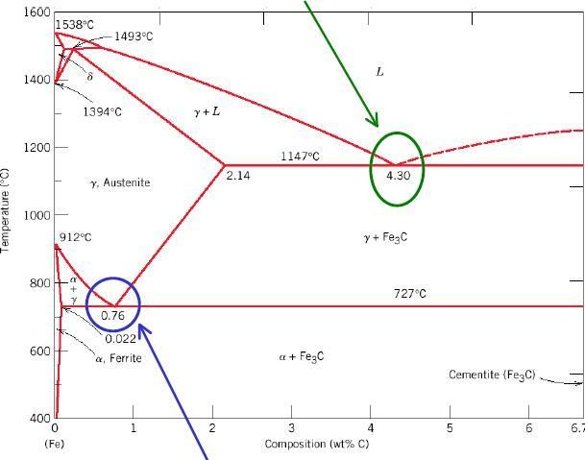
Eutectoid: 0.76 wt %C, 727 °C

γ (0.76 wt% C) ↔ α (0.022 wt% C) +
Fe3C Eutectic: 4.30 wt% C, 1147 °C
L ↔ γ + Fe3C
Eutectic and eutectoid reactions are very important in heat treatment of steels

TTT Diagrams
- The family of S-shaped curves at different T is used to construct the TTT diagrams. The TTT diagrams are for the isothermal (constant T) transformations (material is cooled quickly to a given temperature before the transformation occurs, and then keep it at that temperature).
- At low temperatures, the transformation occurs sooner (it is controlled by the rate of nucleation) and grain growth (that is controlled by diffusion) is reduced.
- Slow diffusion at low temperatures leads to fine-grained microstructure with thin-layered structure of pearlite (fine pearlite).
ATMECE
- At higher temperatures, high diffusion rates allow for larger grain growth and formation of thick layered structure of pearlite (coarse pearlite).
- At compositions other than eutectoid, a proeutectoid phase (ferrite or cementite) coexist with pearlite.
- Additional curves for proeutectoid transformation must be included on TTT diagrams.

Formation of Bainite Microstructure (I)

If 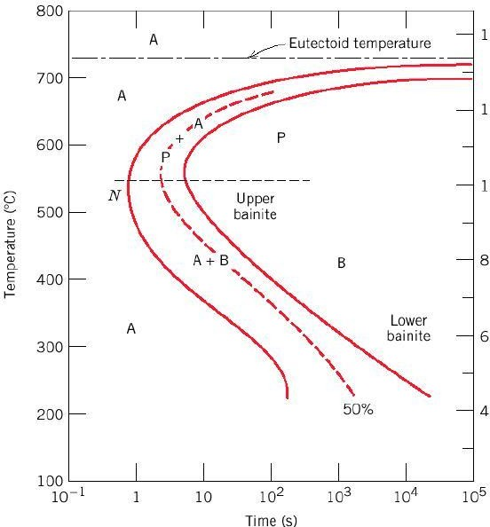

Formation of Bainite Microstructure (II)
- For T ~ 300-540°C, upper bainite consists of needles of ferrite separated by long cementite particles
- For T ~ 200-300°C, lower bainite consists of thin plates of ferrite containing very fine rods or blades of cementite
- In the bainite region, transformation rate is controlled by microstructure growth (diffusion) rather than nucleation.
- Since diffusion is slow at low temperatures, this phase has a very fine (microscopic) microstructure.
- Pearlite and bainite transformations are competitive; transformation between pearlite and bainite not possible without first reheating to form austenite

Upper bainite Lower bainite Spheroidite
- Annealing of pearlitic or bainitic microstructures at elevated temperatures just below eutectoid (e.g. 24 h at 700 C) leads to the formation of new microstructure – spheroidite - spheres of cementite in a ferrite matrix.
- Composition or relative amounts of ferrite and cementite are not changing in this transformation; only shape of the cementite inclusions is changing.
- Transformation proceeds by C diffusion – needs high T.
- Driving force for the transformation - reduction in total ferrite - cementite boundary area

ATMECE
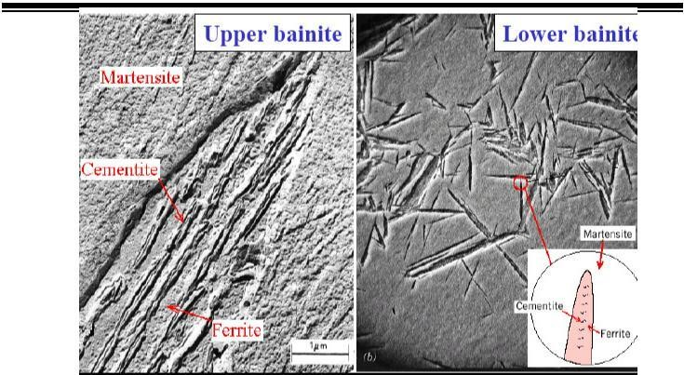

Martensite (I)
- Martensite forms when austenite is rapidly cooled (quenched) to room T.
- It forms nearly instantaneously when the required low temperature is reached. The austenite- martensite does not involve diffusion → no thermal activation is needed, this is called a thermal transformation.
- Each atom displaces a small (sub-atomic) distance to transform FCC γ-Fe (austenite) to martensite which has a Body Centered Tetragonal (BCT) unit cell (like BCC, but one unit cell axis is longer than the other two).
- Martensite is metastable - can persist indefinitely at room temperature, but will transform to equilibrium phases on annealing at an elevated temperature.
- Martensite can coexist with other phases and/or microstructures in Fe-C system
- Since martensite is metastable non-equilibrium phase, it does not appear in phase Fe-C phase diagram

Summary
A phase in a material is a region that differs in its microstructure and /or composition from another region. Phase diagrams are graphical reprentations of what phases are present in a materials system at various temperatures and pressures and compositions. Most phase diagrams are constructed by using equilibrium conditions and used by engineers and scientists to understand and predict many aspects of the behaviour of materials. The different forms of iron and carbon are α-ferrite, γ-austenite, δ-ferrite. TTT diagrams are

ATMECE
17ME32
for the isothermal (constant T) transformations (material is cooled quickly to a given temperature before the transformation occurs, and then keep it at that temperature).

Self assessment questions
- Draw iron carbon equilibrium diagram and mark on it all salient temperatures, composition and phases involved. Elaborate the invariant reactions.
- Construct a phase diagram using the following data and label all the fields Melting point of Ag = 961oC melting point of copper = 10830C Eutectic temperature = 7800C Eutectic composition = 28%Cu maximum solubility of Cu in Ag = 9% at 7800C maximum solubility of Cu in Ag = 2% at 00C. Determine the following. Solidification start and end of temperature for 30% Ag alloy, temperature at which a 15% Cu alloy has 50% liquid phase and 50% solid phase
- What is a phase diagram?. Clearly explain the different predictions that can be made from phase diagram.
- Draw the iron carbon equilibrium diagram and label all the parts.
- With the help of a iron carbon diagram explain cooling of steel with 0.6% carbon showing the microstructure at different stages.
- What is an invariant reaction? Write the following binary invariant reactions 1) Eutectoid
2) peritectic
- Calculate the amount of proeutectoid ferrite, total ferrite and cementite in 0.6% C steel at room temperature.
- Draw the TTT diagram for eutectoid steel and explain the different microstructures obtained at various cooling rates.
- What is critical cooling rate?
- Two metals A and B melt at 6000C and 4000C respectively. They do not form any intermediate phase. The maximum solid solubility in each other is 4% down to 000C.an eutectic reaction takes place at a composition of 65%A-35%B at 3000C. Draw the phase diagram and label all regions. Find the temperature at which a 20% A-80%B alloy starts and completes solidification. Find the temperature at which the same alloy is 50% solid and 50% liquid.

MODULE – 4
Heat Treatment of Metals and Alloys
CCT and TTT diagrams, heat treatment of metals: Annealing method and its types. Normalizing, hardening, tempering, mar tempering, austempering. Hardenability-Jominy-end quench test, surface hardening methods:carburizing, cyaniding, nitriding, flame hardening and induction hardening, age hardening of aluminium-copper alloys.

Every material has its own set of properties, i.e., strength, ductility, toughness, heat resistance, corrosion resistance etc. Heat treating is a group of industrial and metalworking processes used to alter the physical, and sometimes chemical, properties of a material. The most common application is metallurgical. Heat treatments are also used in the manufacture of many other materials, such as glass. Heat treatment involves the use of heating or chilling, normally to extreme temperatures, to achieve a desired result such as hardening or softening of a material. Heat treatment techniques include annealing, case hardening, precipitation strengthening, tempering and quenching. It is noteworthy that while the term heat treatment applies only to processes where the heating and cooling are done for the specific purpose of altering properties intentionally, heating and cooling often occur incidentally during other manufacturing processes such as hot forming or welding.

PURPOSE OF HEAT TREATMENT
The purpose of heat treatment is to achieve one or more of the following objective.
- To improve mechanical properties such as tensile strength, impact resistance, ductility, etc. ,in metals.
- To increase resistance of the metal to wear, heat and corrosion.
- To increase the toughness or resistance to Fracture, of the metal.
- To improve machinability.
- To produce hard surface and tough interior portions.
- To refine the grain structure after hot working a metal.
- To remove strain hardening of a cold worked metal, and to improve its ductility.
- To relieve the internal stresses set up during cold working, casting, welding, and other related processes.
- To improve magnetic and electrical power.

Types of Treatment Processes
There are many ways in which metals are heat treated. From the syllabus point of view, the following heat treatment processes are discussed
- Annealing Full annealing process annealing stress-relief annealing spheroidizing

Normalizing
- Hardening
- Tempering
- Austempering
- Martempering
- Surface hardening
- Case hardening or Carbudizing Solid or Pack carbudizing. liquid Carbudizing. Gas carbudizing., cyaniding , Nitriding. Induction hardening.
v) Age or Precipitation hardening.

ANNEALING
Annealing is a heat treatment process,in which the metal is heated to a high temperature,holding(soaking) it there for a considerable time,and then allowing it to cool to room temperature at a predetermined rate. Heated the metal to high temperature allow diffusion process to occur fast.Also the holding time at the high temperature is long enough to allow desired phase transformation to occur. The metal is then cooled slowly to room temperature to avoid the distortion(warping) of the metal piece, or even cracking
,caused by stesses induced by differential contraction due to inhomogenities.

Purpose of Annealing
The purpose of annealing is to achieve one or more of the following objectives:
- To relieve internal stresses induced by some primary processes,say rolling,forging,uneven cooling etc.
- To remove coarsencess of grains.
- Soften the metal, so as to improve machinability,formability,and sometimesto control magnetic properties

Types of Annealing
- Full annealing
- Process annealing or sub-critical annealing
- Spheroidizing annealing

Full Annealing Purpose
To relieve internal stresses,improve ductility and grain refinement.

Process
The process consist of heating the metal(steel) above the upper critical temperature(in the austenitic zone),holding it there for a considerable time,so that it becomes completely austenitic, and then allowing it to cool slowly in the furnace. Slow cooling associated with full annealing enables the austenite to decompose to form:
- A pearlite+ferrite structure in case of hypo-eutectoid steels. A pearlite+cementite
structure in hyper eutectoid steels.

The phase re-crystalize cpmpletely in this process,and the structure is refined. The metal gets softened with improved mechanical properties. Temperature range
Below fig shows the temperature region on the Iron-carbon phase diagram for full annealing process.
For hypo-eutectoid steels(<0.83%C), the metal is heated to about 50-90°C above upper critical temp (A3 line in diagrams),i.e., to the austenitic phase.
For hyper-eutectoid steels(>0.83%C), the metal is heated to about 50-90°C above the lower critical temp (A1 line) ,i.e., above eutectoid temperature.

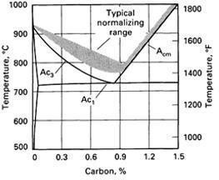

Holding or Soaking Time
Holding time depends on thickness or diameter of the component to be treated.

Application
Full annealing is used for low and medium carbon steels that will be machined, or will experienced extensive plastic deformation during formation operation.

Disadvantage
Process is time consuming due to slow cooling rates in the furnace.

Process Annealing or Sub-critical Annealing
Deforming a metal that has been strengthened by cold working process requires a lot of energy. Process annealing is used to revert the effort of cold work,i.e., to softened and increased the ductility of a previous strain or work hardened metal permitting further deformation.

Purpose
To soften and increase the ductility of a previously strain hardened metal.

Process
The process consists of heating the metal in the range of 550-650°C,which just below the lower critical temp on the Fe-C diagram for steel. The metal is held on this temp for a certain duration and then cool slowly usually in air in order to soften the metal for further cold working, as in the case of wire drawing operation. this process leads to recrystalization prior to process annealing, the grain may have been deformed by cold working process afterward having a new grain structure with no deformation the effort of this treatment is to give a reduction in hardness and increase in ductility.

Temperature Range
Heating Temperature ranges from 550-650°C, which just below the lower critical temperature of steel on the iron-carbon diagram.below fig shows it.

Application
Process annealing is often used during cold water process with low C steel(<0.3%), where the material has to be made more ductile and stresses have to be relieved for the deformation process to continue. Stress Relief Annealing
Stress relief annealing is used to eliminate or minimize the internal residual stresses arising from the following.
- Plastic deformation during machining and grinding.
- Non-uniform cooling of a metal that was processed or fabricated at an elevated temperature such as in welding or casting.
  - Phase transformation that is induced upon cooling ,where in the parent product phase have different densities.

If the stresses are not removed(relieve) , distortion or warpage of the metal may take place. Stress relief annealing allows the residual stress to relax.

Purpose
To remove (relieve) internal residual stress.

Process
The process of heating the metal much below the lower critical temperature, held there long enough to attain a uniform temperature , and finally cooled to the room temp in contact of air.Annealing temperature is relatively low,so that the effect resulting from cold working and other heat treatment are not affected. The internal stresses are relieved to major extent without loss in strenghth and hardness of metal.

NORMALIZING or AIR QUENCHING
Normalizing or Air quenching is a heat treatment process, in which the metal is heated to about 50 degree c above the upper critical temperature, holding it there for a certain duration, and then allowing it to cool in the surrounding air to room temperature.

Purpose
- To refine the grain structure
- To produce a more a uniform and desirable grain size distribution that result in a harder and stronger steel
- To improve mach inability and

To obtain a relatively good ductility without reducing the hardness and stress Figure shows the normalizing temperature region on the iron carbon phase diagram.

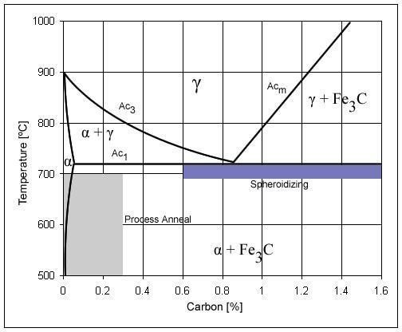

Process
The metal is heated to about 50c above the upper critical temperature(A3 and Acm line),held there for certain direction, and then allowed to cool in the surrounding air to room temperature. Normalizing process is similar to full annealing, but has a faster rate of cooling. The result of such a treatment is a ferrite and pearlite microstructure for hypo-eutectoid steel, pearlite structure and cementite structure for hyper-eutectoid steel,and only pearlite structure for eutectoid steels.

Application
Normalizing is usually performed on rolled and cast steels, an components subjected to high stesses, and on high carbon steels.

NORMALIZING v/s ANNEALING
Table below gives a brief comparison between normalizing and annealing process.

S.NO. | NORMALIZING | ANNEALING
1. | Normalizing can be applied above the  critical temperatures for both hypoeutectoid and hyper-eutectoid steels. | Annealing is applied above the upper critical  temperature for hypo-eutectoid steel and slightly above or below the lower critical temperature for hypereutectoid steel.
2. | Faster cooling rate. | Relatively slow.
3. | Hardness and strength obtained is slightly  greater than those occurred with annealing. | Relatively low.
4. | Finer grain size. | Comparatively less finer.
5. | Normalized ports are soft and easily  machinable. | Comparatively lesser soft.
6. | As the carbon content increases, the  ductility of the normalized high carbon steel drop to 1-2% level. | As the carbon content increases, annealing  maintains the percentage elongation by around 20%.

HARDENING AND QUENCH HARDENING
Hardening is a heat treatment process carried out in order to increase the hardness of steel. Steels can be heat treated to high hardness and strength levels. This is required because structural components subjected to high operating stresses need the high strength of an hardened structure. Similarly, tools such as dies, knives, cutting tools and forming devices need a hardened structure to resist wear and deformation. The hardening of steel requires the formation of martensite, because martensite has the strongest microstructure than pearlite and austenite.

Process
Hardening involves heating steel with a suitable carbon percentage to temperatures about 30-50°C above the upper critical temperature, so as to produce an austenite structure. It is held at this temperature for a duration of about 15-30mins per 25mm of cross-section of steel specimen, and then cooled rapidly in a suitable medium say water, brine, oil, etc. This rapid cooling result in the transformation of austenite to martensite that is responsible for increasing the hardness of steel.
To achieve a full conversion of austenite into hard martensite cooling needed to be fast enough to avoid partial conversion of austenite into pearlite or bainite. Refer iron carbon diagram shown in
fig 5.27. However during the quenching treatment it impossible to cool the steel specimen at a uniform rate throughout. In other words the surface layer at martensite, and the inner core pearlite+martensite. Hence the full martensite conversion is not achieved. Thus the martensite content and hence the hardness will drip from a high value at the surface to a lower value in the interior regions of the specimens. Production of uniform martensitic structure throughout the cross-section of the specimen depends on three factors.

Composition of The Alloy
In steels the maximum increase in hardness by quenching is obtained if the content carbon content between 0.35-0.6%. Increase in carbon content results a decrease in ductility and also has other effects on the material properties.

Quenching Medium
Cooling is faster in water, then oil and slow in air. First cooling is usually accompanied by large thermal gradients and as a result induces residual stresses, brings the danger of warping of the hardened part and formation of cracks.
Size and Shape of the Specimen
Cooling rate depends upon extraction of heat of the surface of the specimen. Thus the greater is the ration of surface area to volume deeper the hardening effect spheres cools slowest, irregular shaped objects fastest.

Hardenability
The term hardenability is used as a measure of the depth of martensitic hardened introduced into steel by quenching. In other word, it is the ability of the metal to be hardened by forming martensite.The term hardening should not be confused to hardness, which is defined as the resistance to indentation; rather harden ablity is a qualatitive measure of the rate at which hardness decreases with distance from the Surface of the specimen due to decreased martensitic content. A metal with high hardenabilty implies the ability of a metal to produce a high martensitic content through out the volume of specimen.

THE JOMINY END-QUENCH TEST
Hardenability is measured by jomony end-quench test under stnd. Condition using standard cylindrical specimen,standard austinizing condition and standard quenching condition, refer below fig.
A standard specimen of 25.4 mm in diameter(1 inch) nd 100mm long is heated in a furnace to the austinizing temperature(above A3 line) for a prescribed time.the specimen is strictly remove from the furnace and then mounted in a fixture as shown below.the lower end of the specimen is quench by a jet of water at a specific flow rate and temperature(24°c) as shown in fig. this result is different rate of cooling along the entire length of the test specimen. After the specimen has cooled to room temperature,shallow flat of 0.4mm deep are ground long the length of the specime,and Rockwell hardness measurement are made of suitable length intervals. The hardenability curve is plotted with hardness as a function of position from the quench end of the specimen.refer fig below.

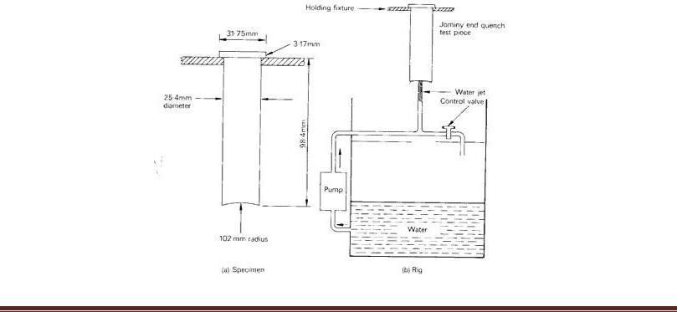

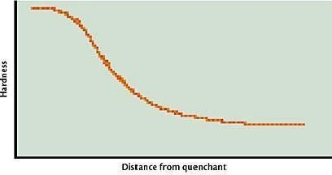

The specificant point about the jominy test result is not that they give hardness at diff distances along the test specimen,but they give the hardness at diff cooling rate. Each distance along the test is corresponds to the diff rate of cooling.the fasted-st rate of cooling occurs at the lower end of the specimen where the jet of water impinges first.Hence the lower end exhibits maximum hardness.asits clear in the hardenability curve in below.since hardness is proportional to amount of martensite from,it also means that 100% matensite is form at the lower end of the test specimen.
It is also clear from hardenability curve that,the hardness increases in distance from the quench end, indicating decrease in cooling rate.with diminishing cooling rate,more time is allowed for carbon diffusion and the formation of greater proportion of the softer pearlite,which may be mixed with martensite and bainite.
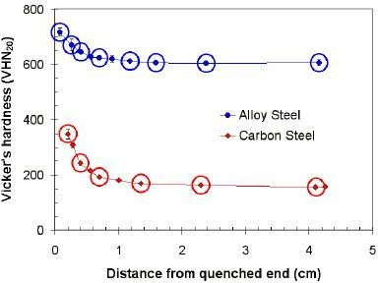

To illustrate the use of jominy test result in the selection of steels,consider the hardenability curve for two diff steels shown in the fig above.
It can be concluded from the graph that,the alloy steel is said to be had better hardenability than the plain carbon steel.this implies that,the alloy steel can be retain large hardness values for relatively long distance(in the specimen) when compared to palin carbon steel.

TEMPERING
Steels subjected to hardening treatment posses martensitic microstructure,which is the strongest structure than pearlite and austenite. Although martensite is a very strong phase,it is normally very brittle. Even slight impact may cause Fracture, of the hardened metal. Hence it is nessesary to modify the properties,and this done by means of tempering process.

Tempering is a heat treatment process that reduces the brittleness of steel without significantly lowering its hardness and strength. The tempering forms an essential operation that has to be performed after hardening.

Purpose

- to reduce brittleness of hardened steel(ductility increases).
- To improve toughness of steel
- To relieve internal stesses,and
- Increase percentage elongation at high temperature.

Process
Tempering is done immediately after quench hardening.when the steel cools to about 40°C.The process involves reheating permits partial transformation of martensite, and relieving of internal(residual) stesses. With increasing tempering temperature,transformation of martensite occurs at a high rate. Based on the reheating temperature range of hardened steel,tempeting may be classified as follows:

Low temperature tempering
carried out in temperature range from 150-250°C
Toughness and ductility increases without significant loss in hardness structure still contains hard martensite Internal stresses are reduced
Applied to cutting tools made from carbon steels and low alloy steels,and case hardened components.

Medium Temperature Tempering

carried out in temperature range from 350-450°C
Hardness and strenghth of steel decreases,while ductility/percentage elongation increases.
Heating in medium temperature ranges causes the transformation of martensite into a less brittle struvture,i.e.,a fine pearlite structure termed as troostite. Applied to components such as coil springs,laminated springs,beams,axles,hammers,chisels,etc.

High Temperature Tempering
carried out in the tem[perature range fram – 500-650°C. Develops a coarse spheroidal structure known as sorbite. Eliminates internal stresses completely Imparts high ductility with adequate hardness. applied to components such as connecting rods,shafts,gear,etc.

AUSTEMPERING
In the austempering process the end product is 100% bainite. The process involves a heating a steel specimen to austenite state,i.e., above the upper critical temperature(A3 line),followed by cooling rapidly in a salt bath held in the bainite range,i.e.,usually between 205-425°C. the specimen is left in the bath until the austenite is completely transformed to bainite. The specimen is then allowed to cool in the air to room temperature. It is important to nate that,the initial rapid cooling(quenching) must be at rate greater than or equal to the critical cooling rate,so that no pearlite is formed.the final cooling rate for the bainite structure can be at any rate as no further changes takes place
.below fig shows the above sequence of events on a TTT diagram.

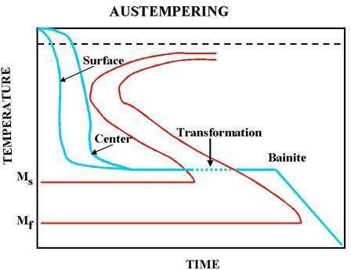

Bainite structure have stenghts slightly lower than martensitic structure,but

have better ductility and impact toughness. Since the steel doesnot suffer a severe quenching treatment.it is less likely to crack and distort. However austempering suffers from major drawback. In austempering,the steel specimen is cause to go directly from austenite to bainite. This means that the section must be cooled fast enough to avoid the formation of pearlite. Thin section can be cooled faster than bulky sections. For this reason,austempering is limited to sections less than ½ inches thick which can be increased by use of alloy steels.

MARTEMPERING
During the quenching treatment, it is impossible to cool the specimen at at a uniform rate throughout. The surface of the steel specimen will cool more rapidly than the interior regions.hence the surface layers are martensitic,while the inner core pearlite+martensite. Also,rapid cooling ends in distortion and warping, residual stresses and crack formation in the component. These effects are overcome by the martempering process.
Maretmpering or marquenching is a hardening treatment,which permits the transformation of austenite to martensite to take place at same time throughout the structure of the steel component with minimum distortion and residual stresses.
Martempering minimize cracking and distortion cracking and distortion,and also reduce the thermal shock of the quenching process. However, hardness and ductility are almost similar to those obtain by direct quenching to the martensite state followed by tempering. Martempering iss followed by tempering process in order to increase the ductility of the steel specimen. Fig below fig shws the sequence of the martempering process followed by tempering process on the TTT diagram.
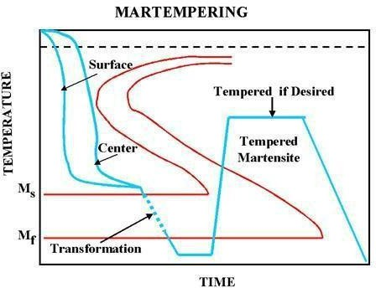

SURFACE HARDENING
Material used in certain industrial applications like cams, gears, axles, etc requires a hard wera resistant surface called case, and a relatively soft, tough and shick resistant inside inside, called the core. surface hardening or surface heat treatment is a process that includes a wide variety of technique to obtained a very hard surface on the component to wear resist along with a tough interior to resist the impact that occurs during the operation. There is two distinctly different approaches to the various method for surface hardening.table below shows the engg methods for surface hardening of steel.
The first group of surface hardening method(layer additive) involves an intentional build-up or addition of new layer,while the second group(substrate treatment) involves surface or subsurface modification without any intentional build-up or increase in part dimensions.the second group method is further divided into diffusion method and selective hardening method.

Sl  No. | Group 1 : Layer additions | Group 2: Substrate treatment
1. | Hardfacing  Fusion hardfacing  thermal spray process | Method 1- Diffusion methods  Carburizing nitriding
carbonitriding
nitrocarburizing
Titanium-carbon diffusion
2. | Coatings plating  Electrochemical ,  chemical vapour deposition,  Physical vapour deposition, ion mixing. | Method 2- selective hardening method  Flame Hardening Induction Hardening  Laser Hardening Ion implantation  Selective carburizing and nitriding.

Diffusion Methods (Case Hardening Methods)
Diffusion method modify the chemical composition of the surface by diffusing interstitial elements like carbon or nitrogen into the surface of steel components. Diffusion method allow effective hardening of surface of the steel components. The various techniques classified under this category include:

    - Carburizing pack carburizing
    - Cyaniding
    - Nitriding
Gas carburizing liquid ccarburizing

Carbonitriding etc.

Selective Hardening Method
Selective hardening methods involve localized hardening or transformation hardeningfrom heating and quenching. However, a few selective hardening methds like selective nitriding or ion implantation and ion beam mixing are based solely on compositional modification.the various techniques classified under this category include:
- Flame Hardening
- Induction Hardening
- Laser Hardening
- Selective carburuzing and nitriding,etc.

CARBURIZING
Carburizing is a method of introducing (adding) carbon to the surface of low- carbon steels in order to produce a hard case (surface), while the inner core remains soft and ductile. Components such as gears,cams,cam shafts,pins,pistons,etc., are hardened by this method. Carburizing increases the carbon content of the steel surface by the process of absorption and diffusion. Hardening is accomplished when the high carbon surface layer is quenched to form martensite structure. A high carbon martensite case with good wear and fatigue resistance is superimposed on a low carbon steel case. The inner core remains soft and dutile.
Carburizing process is usually carried out on low carbon steels containing less than about 0.2%C. The process increases the carbon content to about 0.7-0.8% in the surface layers(to a contain depth). The surface carbon is however limited to about 0.9%, because too high a carbon content can result in retained austenite and bainite martensite.

Characteristics
- Depth of Hardening
There is no limit to the depth of hardening with carburizing techniques, but it is not common to depths in excess of 0.050inch.

Carburizing time and temperature
The time from carburizing ranges from 4-10 hours depending on the type of component being hardened. The temperature ranges from 900-950°C i.e., above the upper critical temperature.

Method
There are three general methods of carburizing based on the carburizing medium or atmosphere. These include:
- Pack carburizing , employing solid carburizing medium
- Gas carburizing, employing suitable hydro-carbon gases.
- Liquid carburizing,employing fused baths of carburizing salts.

Pack Carburizing
In this process, the steel specimen to be carburized is packed in a sealed metal container in such a way that it is completely surrounded by granules of charcoal. Refer below diagram. The charcoal is treated with an activating chemical such as bariun carbonate, which energizes or accelerates the carburizing process.
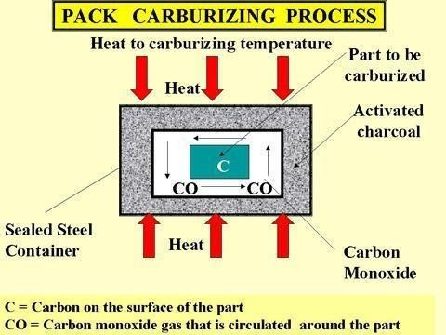
In operation ,the steel specimen is heated to about 900-950°C, which is above the upper critical temperature.It is held at this temperature for a certain period depending on the depth of the case desired. The oxygen present in the container reacts with the carbon content present in the charcoal to produce CO. This carbon-rich atmosphere in contact with the hot steel results in carbon diffusing into the surface layers of the steel component.

Gas Carurizing
In this process , the component to be carburized is heated to about 900°C(above upper critical temperature) for a duration of about 3-4 hours in a furnace in an atmosphere of
carbon-rich gas like methane,ethane,propane,or natural gas. The hydro carbons in the carburizing gas decompose At high temperature, and the carbon diffuses into the surface austenite layers. The depth of hardened case depends on the rate of the gas flow. Gas carburizing is the most widely used method of carburizing.

Liquid Carburizing
Liquid carburizing is the modification of cyaniding heat treatment process. The process is employed primary for relatively shallow cases(0.1-0.25m), Which can be produce at a cost lower than that done by pack or gas carburizing. The process is carried out in baths containing 20-50% sodium cyanide(NaCN), together with upto 40% sodium carbonate,and varying amount of sodium and barium chloride.the reaction takes place during the process is given below:
2NaCN + 2O2 → Na2CO3 + 2N + CO
The carbon from the molting salt diffuses into the steel specimen.in addition, there is also diffusion into the specimen. Both the carbon or nitrogen can result in microstructure that can be hardened by further cooling the steel specimen. Cycle time for liquid carburizing is much shorter (1-4 hrs) than that for gas and pack carburizing processes. Safe disposal of salt ( poissionous elements ) is a major disadvantage of the process.

CYANIDING
Cyaniding involves diffusion of both carbon and nitrogen into the surface of the steel specimen. The steel specimen to be case hardened is immersed in a molten bath of NaCN maintained between 800-870°C for a period of 30 mins-3 hrs depending on the depth of the case required. The carbon and nitrogen from molten bath diffuses into the component of to from hardened carbide-nitride case. The component is then quenched in oil or water to obtain a hard surface. A case depth of 0.1-1mm may be produced by this process.
Cyaniding increases the fatigue limit of steel. It requires short duration to complete the diffusion process. However health and safety hazard process by the poisonous cyanide forms a major disadvantage of the process.

NITRIDING
Nitriding involves diffusion of nitrogen into the surface of certain types of steels containing aluminium, chromium, molybdenum, tungsten and vanadium. The process produce a hard case without quenching or any further heat treatment.However , prior to nitriding, stell must be hardened and tempered to the properties required at the core. Fig below shows the arrangement for nitriding process.
In this process, the steel specimen is heated in an atmosphere of ammonia gas, the temperature being in the order of 500-580°C. At this temperature ammonia dissociate into nitrogen and hydrogen as given in the equation below.
2 NH3 → 2N + 3H2

Nitrogen diffuses into steel specimen, while hydrogen is exhausted. The time taken from the nitrogen to react with the elements on the surface of the steel specimen is often as much as 100 hrs. The depth to which the nitrides are formed in the steel specimen depends on the temperature and the time allowed for the reaction. Even with some long times, the depth of hardening is unlikely to exceed about 0.7mm. After the treatment the component is allowed to cool slowly in the NH3 atmosphere.
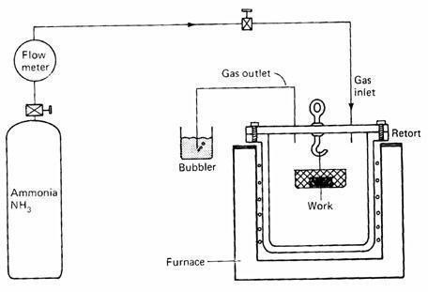
The advantage of this process is that, hardening is achieved without the oil, water , or air quench. Also, hardening in the presence of nitrogen atmosphere prevents scaling and distortion of the specimen(components).

CARBONITRIDING
Carbonitriding involves diffusion of both carbon(C) and nitrogen into the surface of the steel specimen. The process is carried out in a gaseous atmosphere furnace using a carburizing gas such as methane and propane mixed with several percent of ammonia. Methane and propane serve as a source of carbon, while ammonia serves as a source of nitrogen. Quenching is done in a gas medium which is not as severe as water quench. As a result, there is less distortion in the heat treated specimen.
Carbonotriding is carried out at temperature ranging from 850-900°C for a new hours depending on the case depth desired.

FLAME HARDENING
Flame hardening is a process off selective hardening, which involves heating the surface of a steel specimen with an oxyacetylene flame to the austenite range, and then immediately quenching the surface with cold water. Fig below shows the principle of flame hardening. Heating transforms the structure of the suface to austenite, and quenching changes this audtenite to martensite. Hence only heat surface becomes hard, while the core remains soft and tough. The depth of hardening depends on the heat supplied per unit surface area per unit time. Thus

the faster the flame is moved over the surface, the lesser the depth of hardening achieved. There are three general methods of falme hardening:
- Spot flame Haredening : In this method, the oxyacetylene flame(heating torch) is directed to the spot that needs to be heated and hardened.
- Spin flame hardening : The workpiece is rotated while in contact with the flame.
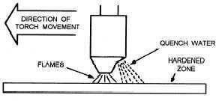
- Progressive flame hardening : The flame and the quenching medium is directed across the surface of the steel specimen.

INDUCTION HARDENING
Induction hardening is a process of selective hardening used to produce a hardand wear resistant surface with a soft core in steel components.
The process involves placing a steel specimen in an indicator coil that compromises several turns of copper tube. The copper tube acts as a primary coil of the transformation and is water cooled. When a high frequency current of about 1000-10000 cycles/sec is passed through the inductor coil, it sets up a magnetic field. This magnetic field induced high frequency eddy currents and hysteresis currents in the steel specimen. The resistance offered by the steel specimen to the flow of current through it results in rapid heating of the surface layer of the specimen. The temperature produced -is in the range of about 700-800°C, Which causes the surface layer to martensite. Thus,only the surface of the specimen gets hardened, while the interior core remains soft.
The depth of heating produced by the method, and hence the depth of hardening is related to the frequency of the AC used. The higher the frequency is, the lesser the hardened depth. The major advantage of this process is this process is its speed and ability to confine heating on small parts. However, the cost and maintenance is higher. Also, low carbon stell(<0.4%C) cannot be hardened by this process.

AGE HARDENING or PRECIPITATION HARDENING
Certain metals and alloys show increase in their hardness after allowing sufficient time at room temperature, or after heating to a slightly higher temperature. This kind of hardening iscalled age hardening, since the strength develops with time, or as the alloy ages. Age hardening is also known as precipitation hardening, because the strengthening of an alloy results from the precipitationof a fine dispersed second phase from a supersaturated solid solution with the passage of time. The alloys that are hardened by this process include: aluminium-copper, copper-beryllium, copper-tin, and magnesium-alluminium; a few ferrous alloys are also hardened by this process. Of all the different combinations of alloying elements, the mechanism of hardening has perhaps been studied most extensively for the aluminium-copper alloys.

Ages Hardening of Aluminum-Copper(Al-Cu) Alloys
Fig below shows a portion of the phase diagram for an Al-Cu alloy of composition 96% Al4% cu. On the right of the phase diagram is shown the resulting microstructure at each step in the hardening process.
Age hardening or Precipitation hardening cocsists of three steps : Solution treatment
Quenching,and
Aging.

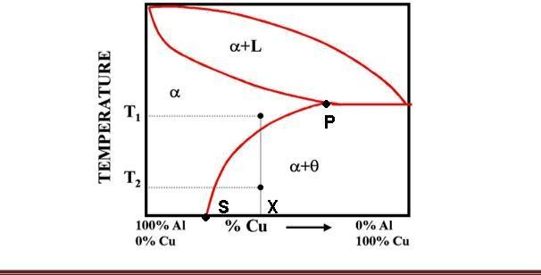

  - Solutiontreatment solution treatment involves heating the certain temperature that causes the alloying atoms to dissolve into the section. This results in a homogeneous solid solution of single phase.
In case of Al-Cu alloy, when the aluminium alloy with 4% Cu is heated to about 550°C and held at that temperature for a while, diffusion will occur and a homogeneous solid section of α-rich in aluminium will form. Refer point no 1 on the phase diagram.

Quenching
Quenching is the second step in precipitation hardening, which rapidly cools the homologous solid solution and freezes the solution. In more technical terms,quenching terms,Quenching cools the material so fast that the atoms of the alloying elements do not have time to diffuse out of solution.i.e.,precipitation will not occur. The solution becomes supersaturated.

Aging
Aging is the process where the solute particles diffuse out of the solution, and into clusters that distort and strengthen the material. This occurs over a prolonged time.
In case of Al-Cu alloy is heated to a temperature of about 165°C (point 3 on the phase diagram) and held at this temperature for about 10 hours. A fine precipitate of CuAl2 comes out of α-phase with the passage of time. The resulting precipitate tends to be very fine particles dispersed throughout the solid. Such a fine precipitate gives a much stronger and harder alloy.

Department of mechanical Engineering
ATMECE

Module-5

Objectives:

Composite Materials

To learn about composites such as
- Classification of Composites
- Types of matrix materials & reinforcements,
- Production of FRP's and MMC's
- Advantages and application of composites.

Outcomes:
- Today's composite materials often outshine traditional materials; they are lightweight, corrosion-resistant, and strong. Used in everything from aircraft structures to golf clubs, and serving industries from medicine to space exploration, composites are an exciting field of study for students, engineers, and researchers around the world. New applications of these versatile materials are being found daily.

Module -5: Composite Materials
Composite materials - Definition, classification, types of matrix materials & reinforcements, Metal Matrix Composites (MMCs), Ceramic Matrix Composites (CMCs) and Polymer Matrix Composites (PMCs), Particulate-reinforced and fiber-reinforced composites, Fundamentals of production of composites, Processes for production of composites, hand layup , bag moulding and Filament winding, Constitutive relations of composites, Numerical problems on determining properties of composites.

INTRODUCTION TO COMPOSITE MATERIALS
Composite materials (or composites for short) are engineered materials made from two or more constituent materials with significantly different physical or chemical properties and which remain separate and distinct on a macroscopic level and are not soluble to each other. one constituent is called the MATRIX and the other is called the REINFORCING phase. examples; concrete, fibre glass,wood
Composite material is a material composed of two or more distinct phases (matrix phase and dispersed phase) and having bulk properties significantly different form those of any of the constituents
The idea is that by combining two or more distinct materials one can engineer a new material with the desired combination of properties (e.g., light, strong, corrosion
resistant). The idea that a better combination of properties can be achieved is called the principle of combined action. New - High-tech materials, engineered to specific applications

17ME32
Strength Stiffness Corrosion Resistance Wear Resistance Attractiveness lessWeight Fatigue life Fatigue life Temperature dependent behavior Thermal insulation Thermal conductivity, Acoustical Insulation

Limitations
High cost of production, Anisotropy, Mechanical characterization difficult Debonding, Delamination, Fiber pullout
Repair of flaws- difficult in metals Recycling-PMC Historical Background
addition of straw to clay in making of mud huts -4000bc glue laminated wood 500 bc
medieval swords and armor made with layers different metals reinforced cement concrete-1800 ad

Classification of composites

Based on reinforcing materials Based on matrix material

PARTICULATE | FIBER | STRUCTURAL | POLYMER | METAL | CERAMIC
REINFORCED | REINFORCED | COMPOSITES | MATRIX | MATRIX | MATRIX

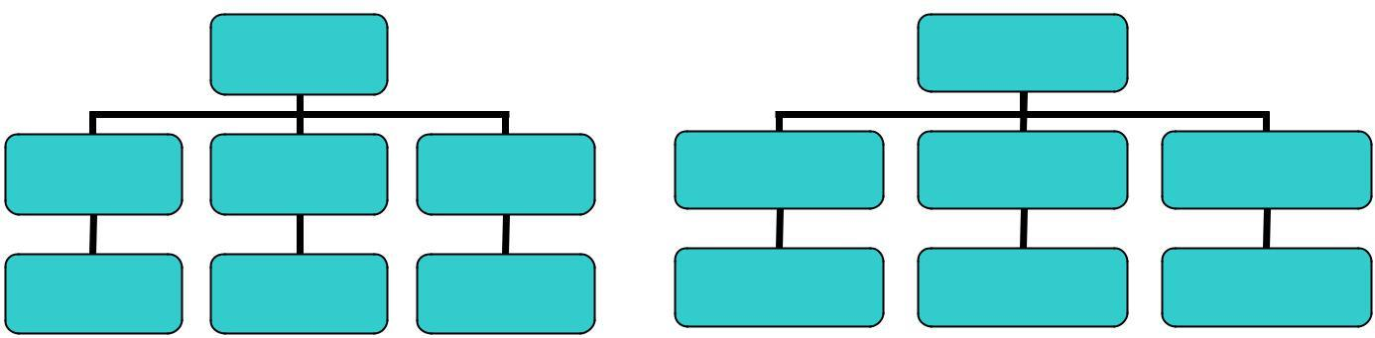Matrix phase The primary phase, having a continuous character, is called matrix. Matrix is usually more ductile and less hard phase. It holds the dispersed phase and shares a load with it
REINFORCING MATERIALS
MATRIX MATERIAL
LARGE PARTICLES DISPEROIDS
CONTINOUS FIBERS DISCONTINOUS( SHOR T)
ALIGNED/RANDOM
LAMINATES
SANDWICH PANELS
THERMO PLASTIC THERMOSETS
LIGHT METALS &ALLOYS
AL, Mg, Li &Ti REFRACTORY METALS
(Co,W)
CERAMICS

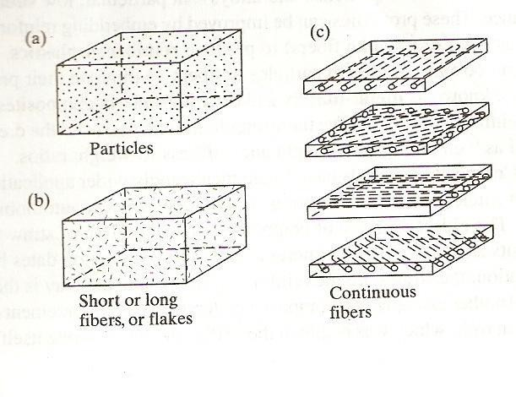:
Reinforcement Phase Discontinuous phase,

Particle Reinforced composites Fiber reinforced composites
Particulate reinforced composites consist of particles of one or more materials suspended in a matrix of another material. The particles can be either metallic or non metallic as can the matrix. The four different combinations are
Nonmetallic particles in Nonmetallic Matrix Concrete- a mixture of sand, gravel, cement & water Glass flakes in plastic resins

17ME32

Metallic particles in Non metallic matrix
Copper in Epoxy resin increases the conductivity Aluminum paint – Suspension of aluminum flakes in Paint
Metallic additives to plastics improves the thermal conductivity, lowers the coefficient of thermal expansion and reduces the wear

Metallic particles in Metallic Matrix
Lead alloys in copper alloys to improve machinability, where lead is a natural Lubricant Tungsten, Chromium (hard materials) suspended in ductile materials

Non metallic particles in Metallic Matrix
Chromium carbide in a Cobalt matrix has high corrosion and abrasion resistance Uranium oxide in stain less steel as a control rod in nuclear reactors Ceramics suspended in metal matrix called as cermets.

Fiber reinforced composites:
Fibers are one of the oldest engineering materials in use. Jute, flax, hemp have been used for such products as rope, nets, water hose, and containers since antiquity. Plant fibers and animal fibers are used for papers, brush, or heavy structural cloth. Many synthetic fibers have been developed to replace natural fibers, because synthesis has more predictability and uniform in size. For engineering purposes glass, metallic, and organically derived synthetic fibers are most significant. Nylon is used for belting, nets, hose, rope, parachute, ballistic cloths and reinforcement in tyres.

FIBERS
Glass-high strength low stiffness, high density lowest cost Graphite-high strength low cost less dense than glass Boron-high strength & stiffness high density, highest density Aramids- highest strength to weight ratio of all fibers, high cost
Other fibers nylon silicon carbide silicon nitride aluminum oxide boron carbide boron nitride tantalum carbide aramids/ Kevlar

Chemical composition of different glass fibers
Constituents | E-glass | S-glass | C-glass
SiO2 | 54 | 64 | 65
Al2O3 | 15 | 25 | 4
CaO | 17 | <1 | 14
MgO | 4.5 | 10 | 3
B2O3 | 8 | - | 5
Others | 1.5 | 0.8 | 8

17ME32
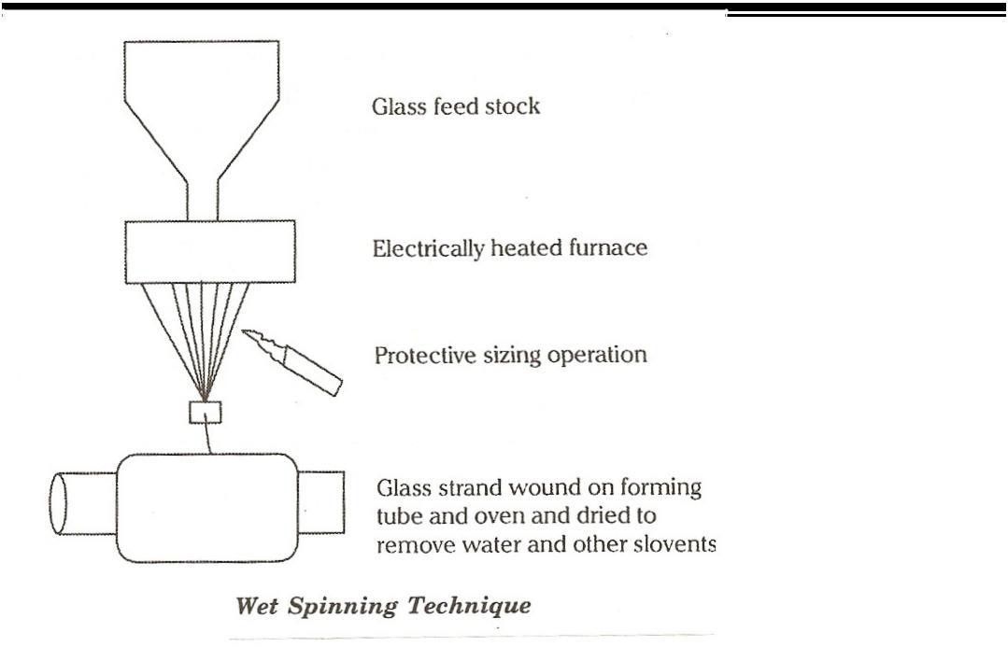
Factors for Glass fiber selection
Thermal properties Fiber cost
Type of manufacturing process Forms of reinforcement

Thermal properties of Glass fibers
Glass fibers loose tensile strength as temp increases.
At high temp performance of C glass is inferior to E glass & S glass. Fibers with high CTE expand more as temp increases.
S-glass has much lower CTE than E glass & C glass

Glass Fiber Manufacturing
Sand, Limestone & Al2O3 is fed to Feed stock & heated to 14000C. The melt is stirred at a constant temperature. The melt passes through the platinum nozzles containing around 934 nozzles of 10µmdia. The yarn coming out is wrapped up in the forming tube at a speed of 25m/s. Before the yarn is drawn, sizing is done
Sizing solution consists of
- organic binders- to allow packing of strands
- Lubricants- to prevent abrasion of filaments
- Coupling agents-for better bonding with polymers.
Fibers are drawn in to strands; each strand consists of more than 204 filaments. The wound array of strands are dried in an oven to remove water & other solvents

Forms of Glass fibers
Continuous strands (group of 204 fibers) Rovings (group of parallel strands) Chopped strands (5 to 50mm length) Chopped rovings (5 to 50mm length)
Tow (group of over 10000 fibers).A strand is a collection of continuous filaments
A roving is a collection of untwisted strands. Yarns are collection of filaments or strands twisted together.
Reinforcing fibers for PMC’s are generally Glass, graphite, aramids, boron, and other fibers.

ATMECE
17ME32
Graphite; graphite fibers are more expensive than glass fibers. They have a combination of low density, high strength and high stiffness
All graphite fibers are made by pyrolysis of organic precursors commonly polyacrylonitrile (PAN) because of its low cost. Rayon and pitch (the residue from catalytic crackers in petroleum refining) can also be used as precursors.
Pyrolysis is a process of inducing chemical changes by heat-by burning a length of yarn and causing the material to carbonize and become black in color. The temperatures for carbonizing range up to about 1500 deg C: for graphitizing, to 3000 deg C.
The difference between graphite and carbon fibers depends on the temperature of pyrolysis and purity of material. Carbon fibers are usually 80-95%, graphite fibers are 99% carbon.
Conductive Graphite fibers: are used to increase the thermal and electrical conductivities of the reinforced plastic components. The fibers are coated with metals, usually nickel, by continuous electroplating process. The coating will be around 5 micron thick on a 7 micron graphite fiber core. Applications include electromagnetic and radio frequency shielding and lightening –strike protection.
Aramids: are produced from aromatic polyamide fibers. The trade name is Kevlar produced by DuPont. Kevlar fibers are compounds based on benzene rings. It is manufactured by a process called Dry jet wet spinning process.
Boron: boron fibers consist of boron deposited on tungsten fibers by chemical vapor deposition. These fibers have desirable properties like high strength and stiffness both in tension & compression & resistance to high temperature. Because of the high density of the tungsten they are heavy, expensive.
Other fibers: Nylon, silicon carbide, silicon nitride, aluminum oxide, sapphire, steel, tungsten, molybdenum, boron carbide, boron nitride, and tantalum carbide.
Whiskers are also used as reinforcing fibers. They are needlelike single crystals that grow to from 1 micron to 10 micron in diameter. They have aspect ratios ranging from 100-15000. (Aspect ratio is defined as the ratio of fiber length to fiber diameter.)
Because of their small size whiskers are free of defects. The elastic modulus ranges from 400 GPa
-700 GPa and their tensile strength ranges from 15GPa to 20GPa. Mats - is a non-woven fabric that provide equal strength in all directions Mats are of two types
- Chopped strand-randomly distributed fibers cut in 1.5-2.5 inch, held with a chemical binder (styrene)-used in hand lay up, continuous laminating, closed molding application
- Continuous strand-formed by swirling continuous strands of fiber onto a moving belt, finished with a binder are stronger than chopped strand.
These mats are used in compression molding, resin transfer molding, pultrusion

ATMECE
17ME32

Desirable characteristics of fiber reinforced composites.
While designing a fiber reinforced composites, the following factors have to be considered. Length of the fibers
Diameter of the fibers Orientation of the fibers
Amount or volume fraction of the fibers Physical and Mechanical properties of Matrix Bonding between matrix and fibers.
Length of fibers: Usually the ends of fibers have lower load carrying capability and hence more no of ends will lower the load carrying capacity of the composite. Longer the fiber, no of ends will be lower and hence the load carrying capacity will be higher. An important parameter characterizing the length of the fiber is the aspect ratio (l/d). if the aspect ratio is greater than 15, the fiber is termed as continuous, otherwise it is termed as discontinuous.

Diameter of fibers:
Reducing the diameter of fibers has the following advantages. The numbers of defects are reduced and the strength is increased
ATMECE
17ME32

LAMINAR COMPOSITES
Of all the composites devised the laminar type is the oldest. It differs from the other types by the presence of layers. They are made up of films or sheets. Laminar composites consist of two or more different layers bonded together. The layers constituting a composite can differ in material, form and / or orientation. Laminar composites are anisotropic in nature.
In plywood, though the layers are often of the same material, the orientation differs. A reinforced plastic sheet may be clad with copper to make a printed circuit board
A Lamina is a single layer of uni-directional fibers or woven fibers arranged in a matrix.
The constituents of lamina ie fiber and matrix exhibit different types of stress strain behaviour. Fibers generally show linear elastic behaviour. The fibers or filaments, the main load carrying agent, are strong and stiff. The matrix may be plastic ceramic or metallic. Its function is to transfer the load , support and protect the fibers.
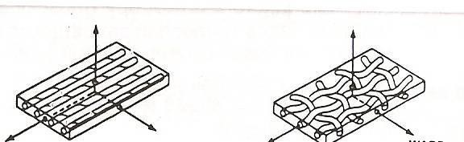

Fig 1 Lamina with unidirectional fibers. Fig 2 Lamina with woven fibers
Laminates are defined as composite materials consisting of two or more superimposed layers bonded together. Laminate is a stack of plies of composites. Each layer can be laid at various orientations and can be different material systems. Laminate is a stack of laminae.
Generally laminates are designed to protect against corrosion, high temp oxidation, to cut costs, to improve appearance etc
Laminar composites can be divided in to laminates and sandwiches.
A major purpose of lamination is to tailor the directional dependence of strength and stiffness of a material to match the loading environment of the structural element.
Sandwiches a special case of laminates, consists of a thick low-density core (such as honey comb or foamed material) between thin faces of comparatively higher density. In sandwich composites the primary objective is to improve the structural performance.

Matrix materials:
POLYMER MATRIX COMPOSITES
Polymers make ideal matrix material as they can be processed easily, possess light weight and have desirable mechanical properties. Polymers in general have poor strength and modulus. They get degraded on prolonged exposure to ultra-violet rays. They also cannot withstand high temperatures. They are poor conductors of electricity and have high coeffient of thermal expansion. Polymers do not have fixed melting point. The temp at which the crystallinity is destroyed is called glass transition temperature. There are two types of polymers a) Thermo plastics b) Thermosets
Matrix materials are usually thermosets. Commonly used are epoxies, polyester, phenolic, fluorocarbons, polyether sulphone or silicone. The most commonly used are epoxies and (80%)

ATMECE
17ME32
and poly esters, which are less expensive than epoxies. Polyamides which resist exposure to temperature in excess of 300 deg C are being developed for use with graphite fibers. PEEK (polyetheretherketone) is also used as matrix material. They have higher toughness than thermosets, but their resistance to temperature in being limited to100 deg-200deg C.
The matrix in reinforced plastics has three functions.
- To support the fibers in place and transfer the stresses to them, while they carry most of the load
- To protect the fibers against physical damage and the environment.
- To reduce the propagation of cracks in the composites, by virtue of the greater ductility and toughness of the plastic material.

METAL MATRIX COMPOSITES:
Metal matrix composites have a metal as a matrix usually a light metal such as Al, Mg, or Ti or a super alloy ( Ni based or Co based super alloy). The reinforcement materials include Boron, Silicon Carbide, carbon, Graphite, alumina, boron carbide, boron nitride. The form of reinforcement material can be either a fiber or whisker or particulate. Metals are reinforced to either to increase certain properties like elastic modulus and tensile strength or decrease certain properties like coefficient of thermal expansion and thermal conductivities.

CERAMIC MATRIX COMPOSITES:
They are hard and brittle, have low toughness, low thermal coeffient of expansion, very low mechanical shock resistance. Examples are
- SiC particles in alumina matrix used as tool materials.
- SiC particles in SiC matrix used as cutting tool inserts. 3.Glass fibers in alumina matrix used in aircraft engine parts. FIBER REINFORCED PLASTIC
PROCESSING: Need for development of composite
materials Advantages of composites:
- High specific Strength and modulus – aerospace industries, automobiles.
- Advantage of moulding in to desired shape and size using open or closed moulding process.
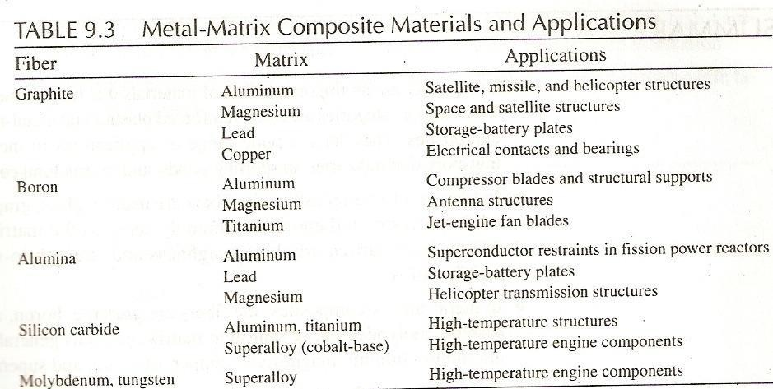

DEFINITIONS
Aspect ratio: The ratio of length to diameter of the fiber.
Coeffient of elasticity: the reciprocal of Young’s modulus in a tension test.
Coeffient of expansion: The fractional change in dimension of a material for a unit change in temperature.
Coeffient of friction: A measure of the resistance to sliding of one surface in contact with another surface.
ATMECE
17ME32
Felt: A fibrous material made from interlocked fibers by mechanical or chemical action, moisture, or heat, made from asbestos, cotton, and glass.
Flexural modulus: The ratio within the elastic limit, of the applied stress on a test specimen in flexure to the corresponding strain in the outer most fibers of the specimen.
Flexural rigidity: For fibers this is a measure of the rigidity of individual strands or fibers. The force couple required to bend a specimen to unit radius of curvature. For plates the measure of rigidity id D = EI where E is the modulus of elasticity and I is the moment of Inertia,
D = E h2/ 12(1-v) mm/N where E- modulus of elasticity, h- thickness of plate, V- Poisson’s ratio
Flexural strength: The resistance of a material to breakage by bending stresses
Notch sensitivity: The extent to which the sensitivity of a material to fracture is increased by the presence of surface inhomogenity such as notch, a sudden change in section, a crack, or a scratch. Low notch sensitivity is usually associated with the ductile materials and high notch sensitivity with brittle materials.
Poisson’s ratio: A constant relating change in cross-sectional area to change in length when a material is stretched.
Resilience: The ratio of energy returned on recovery from deformation to the work input required to produce the deformation- expressed as percentage. 2) The ability to regain an original shape quickly after being strained or distorted.
Stiffness: A term often used when the relationship of stress to strain doesn’t confirm to the young’s modulus of elasticity.

Boron Fibers
Definition: Filaments produced by a chemical vapor deposition process. Boron can be deposited on a tungsten wire core, and on a glass or graphite filament core. The filaments thus produced have nominal diameters ranging from 0.1-0.2 mm. They are characterized by low density, high tensile strength and high modulus of elasticity. They are extremely stiff, e.g., five times stiffer than glass fibers. This stiffness makes boron filaments difficult to weave, braid, or twist, but they can be formed into resin impregnated tapes for hand lay-up and filament winding processes. The high cost of boron filaments has limited their use to experimental aircraft and aero-space applications
Pultrusion: Pultrusion is a continuous, automated closed-moulding process that is cost effective for high volume production of constant cross section parts. Due to uniformity of cross-section, resin dispersion, fibre distribution & alignment, excellent composite structural materials can be fabricated by pultrusion. The basic process usually involves pulling of continuous fibres through a bath of resin, blended with a catalyst and then into pre-forming fixtures where the section is partially pre-shaped & excess resin is removed. It is then passed through a heated die, which determines the sectional geometry and finish of the final product. The profiles produced with this process can compete with traditional metal profiles made of steel & aluminum for strength & weight.
Pultrusion: Process Technology The process begins when reinforcing fibres are pulled from a series of creels. The fibres proceed through a bath, where they are impregnated with formulated resin. The resin-impregnated fibres are preformed to the shape of the profile to be produced. This composite material is then passed through a heated steel die that has been machined precisely to the final shape of the part to be manufactured. Heat initiates an exothermic reaction thus curing the thermosetting resin matrix. The profile is continuously pulled and exits the mould as a hot, constant cross sectional member. The profile cools in ambient or forced air, or assisted by water.

The product emerges from the puller mechanism and is cut to the desired length by an automatic, flying cutoff saw. A schematic representation of pultrusion process is given in following figure:

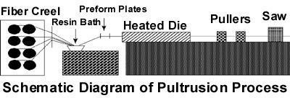

THERMOPLASTIC COMPOSITE PROCESING

THERMO FORMING Thermo forming consists of heating a thermoplastic material to its softening point and forming it against the contour of the mold. Fiber reinceforced thermoplastic such as ABS, nylons, polycarbonates polysulphones, polybuteneterepthalate and PET are used in this method, since they exhibit good melt characteristics even with fiber reinforcements and filler contents of 40% volume or more. Parts are formed by heating the sheet of reinforced thermoplastics to a temperature above the glass transition temperature of the resin and then mechanically forming the sheet in to a mould or over a mandrel. The formed parts cool to a temperature below the plastic range and are removed from the mold. At this point the point the part is still hot and is placed on a fixture to cool to the room temperature. Cycle time varies between seconds to mins.

Thermoforming methods;
There are at least dozen methods of thermoforming Vacuum assisted forming
Pressure forming Plug assisted forming Drape forming
Matched mold forming Slip forming
Free forming

Vacuum Bag Molding

Vacuum bag molding, a refinement of hand lay-up, uses a vacuum to eliminate entrapped air and excess resin. After the lay-up is fabricated on either a male or female mold from precut plies of
glass mat or fabric and resin, a non adhering film of polyvinyl alcohol or nylon is placed over the lay-up and sealed at the mold flange. A vacuum is drawn on the bag formed by the film while the composite is cured at room or elevated temperatures. Compared to hand lay-up, the vacuum method provides higher reinforcement concentrations, better adhesion between layers, and more control over resin/glass ratios. Advanced composite parts utilize this method with preimpregnated fabrics rather than wet lay-up materials and require oven or autoclave cures.

Pultrusion
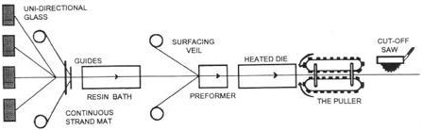

Pultrusion is a continuous method of manufacturing various reinforced plastic shapes of uniform cross sections. Glass reinforcements, such as unidirectional rovings or multi-directional glass fiber mat, are guided through a liquid resin bath to thoroughly wet every fiber. The reinforcements are then guided and formed, or shaped, into the profile to be produced before entering a die. As the material progresses through the heated die, which is shaped to match the design profile, the resin changes from a liquid to a gel, and finally, into a cured, rigid plastic.

A pulling device grips the cured material and literally pulls the material through the die. Hence, the name pultrusion. It is the power source for the process. After the product passes through the puller, it is sawed into desired lengths. Although pultrusion is ideally suited for custom shapes, some standard products include rods, bars, angles, channels, and I-beams.

Summary
Composite materials (or composites for short) are engineered materials made from two or more constituent materials with significantly different physical or chemical properties and which remain separate and distinct on a macroscopic level and are not soluble to each other. One constituent is called the MATRIX and the other is called the REINFORCING phase. Based on reinforcement they are classified as Particle Reinforced composites Fiber reinforced composites. Based on matrix they are classified as PMC, MMC and CMC. Composites have the following advantages over metals such as specific strength, specific weight, design tailorability, use of existing manufacturing process.

Self assessment questions

  - Define composite material and give the classification of composite briefly?
  - Describe the features of fibrous composite, laminated composite and particulate composite?
  - Using neat sketches, explain the process of preparation of MMC?

  - Discuss the role of matrix and reinforcement in a composite material. Write a short note on FRP?

17ME32
  - Explain autoclave & filament winding methods for production of FRP.
  - Compare MMC’s with PMC’s.
  - How the mechanical advantage of composite is measured. What are the limitations of composite materials?
  - What are the applications of composite material?
  - What are FRP’s? Give at least four examples.
  - Discuss briefly advantages and applications of MMC’s and FRP’s.
  - Compare MMC’s with PMC’s.
  - Why and how are composite superior to conventional materials.
  - What are the main types of synthetic fiber used in FRP’s?
  - List at least three commonly used matrix material and reinforcement fibers used in the production of FRP’s.
  - Discuss the role of FRP’s in space, naval and aeronautical engineering

